Mary and Jesus, two special friends: walking with two pillars

  - ADMA Formative Programme 2022/2023

INTRODUCTION

In the year 2022-2023, we would like to go back to the roots of the Association: The devotion of Don Bosco to Mary Help of Christians found in the Association a simple and practical expression for the defence of the faith in popular circles. Don Bosco reminds us that “We Christians must be united in these difficult times. Being among many who are doing good is a source of animation to us, without our being aware of the fact” (MB 7,602) (Art. 1 of the ADMA regulations). We wish, then, to propose an itinerary of faith which can lead us to an encounter with Jesus through the mediation of our Heavenly Mother and this itinerary of faith can propel us towards our apostolic activity.
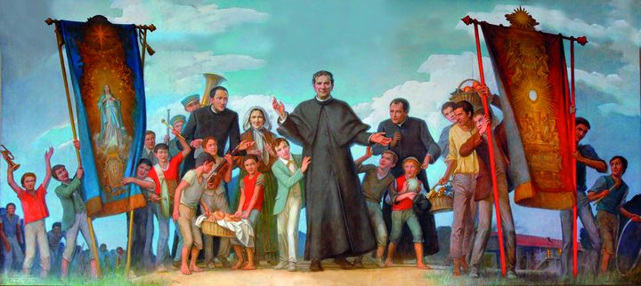
This traditional path of growth in the faith, as we cherish, is inculcated in us through the deepest sources of Christian, Salesian and Marian spirituality. It is new because each associate and each group in the world will live it according to their own life experience. It is enlivened as each associate adapting it to their individual reality. We shall keep inspiring one another for a year in the spiritual journey of Christian life, founded on two pillars, Jesus and Mary, being guided by the Word of God, by Don Bosco and by St Francis de Sales. Let us draw our inspiration from the Regulations of the ADMA, the Charter of Charismatic Identity of the Salesian Family, the Magisterium of the Pope and the teaching of the Rector Major.
The aim of the programme is to deepen our life of faith and progress in our personal relationship with Jesus and Mary.

THE STAGES OF THE JOURNEY
- Feeling loved by God
Our faith becomes life when we deeply experience the love of God.
The Word of God announces to us that “God is Love” (1 Jn 4: 7-16), that Jesus wants to enter into deep communion with each one of us: “As the Father has loved me, so have I loved you” (Jn 15:9-11); “I have come that they may have life and have it abundantly” (Jn 10: 7-15).
We will be invited to meditate on the Word in order to fully cherish God’s tender and boundless love for each one of us. From this experience of feeling loved just as we are, is born the sincere desire to respond to God. We can then understand better St. Francis de Sales when he says, “First of all seek to please God: He is the centre of my soul and the immovable pole around which all my desires and all my movements revolve.”
We will thus be helped to turn our gaze towards Him every day, to feel His love and to give it, in turn, to our brothers and sisters.
- “I stand at the door and knock” prayer
Having grown in our awareness of being profoundly loved, we will focus on our relationship with the Lord, in prayer, with the help of Mary.
Only in the experience of silent listening will we vitally understand Jesus when he says, “Behold, I stand at the door and knock” (Rev 3:20) and “If anyone loves me, he will keep my word and my Father will love him, and we will come to him and dwell with him” (Jn 14: 23) and “discover the secret of the wise virgins” (Mt 25:1-13).
The secret of life, says St. Francis de Sales, is “to go from the inside out: I have never been able to approve the method of those who, in order to reform man, begin from the outside, from the appearance, the clothes, the hair. It seems to me, on the contrary, that one must begin from within.... He who has Jesus in his heart, has him immediately afterwards in all outward actions.”
Prayer shall be the center of our lives which would lead us to all our practical suggestions.
- Children are created in the image of God. Trust in God.
Surrendering to the Holy Spirit, through the hands of Mary, leads us to grow in trust in God. We will contemplate the mystery of God who is not afraid to trust in a human person.
We will deepen the knowledge how the mystery of the incarnation (Lk 2) fits into a wider project of love that preludes the cross: “I come to do your will, O God” (Hebrews 10: 5-10).
Jesus’ only desire is to make it clear by his life that all existence is explained by love, a love so compelling that it led St. Paul to say “I have been crucified with Christ and it is no longer I who live, but Christ who lives in me. This life I live in the flesh, I live in the faith of the Son of God who loved me and gave himself for me” (Gal 2:20). In this profound mystery of love, we are invited to become truly aware of our creatureliness. As St. Francis de Sales suggests, “we must be what we are and be it well, to do honour to the Creator, whose handiwork we are.”
- There is no greater love: the Eucharist
Eucharist is the source and summit of true life that is love and bread of life: Love one another as I have loved you. Do this in memory of me. Let us contemplate the gift that Jesus offers us as the premise and foundation of our adherence to love for Him and for our brothers and sisters. Let us dwell on the Washing of the Feet to understand how Eucharistic life inspires us to fully dedicate ourselves each day in the concrete service of others.
St. Francis de Sales too insists on our day to day service: “Think of doing our things well today and when tomorrow comes, then we will think about it.”
In the light of the mystery of the Eucharist, we will understand the importance of the present moment. In fact, the Eucharist is a real encounter with the Risen Lord in the Word and in the Eucharistic Bread. It assures us of His presence in our daily lives, helps us conform to Him, shows us His deep love for others and gives us true joy.
- Mary, the bride in the Holy Spirit, teaches us to do everything out of love
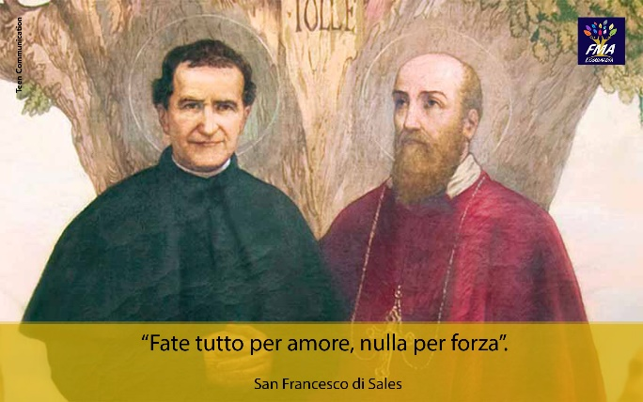
The Holy Spirit enlightens and guides us in our life of faith. We will go to the source of the “yes” of Mary, bride in the Spirit. In the light of the Word, we will discover how Mary’s Fiat can be renewed in our lives. With Mary, mother and teacher, our life recovers its full meaning and is transformed into Magnificat. In this way, love takes on the features of full freedom. St. Francis de Sales says: “Nothing by force, everything by love.” Here is the general rule of our obedience: YOU MUST DO EVERYTHING FOR LOVE AND NOTHING BY FORCE.... I leave you with the spirit of freedom, that which excludes constraint, scruple and restlessness.” As we read in the ADMA Regulations: “Mary is a living presence among us and continues in the history of the Church and of humanity her maternal mission as mediatrix of grace for her children.”
- The primacy of grace: joy, gift of the Holy Spirit (the theological virtue)
The action of the Holy Spirit generates joy in us. It is the outcome of the working of the Virtues of Faith, Hope and Charity. We will rediscover the theological virtues by meditating on the hymn of charity (1 Cor 13:1-13) and other Pauline letters. We will deeply understand the foundation of Salesian joy: “Go ahead with joy and an open heart as much as you can; and if you do not always go with joy, go always with courage and confidence” (St Francis de Sales). This is the Cheerfulness Don Bosco inspired Dominic Savio to follow, “We make holiness consist in always being cheerful.” By following Don Bosco’s path of entrustment to Mary Help of Christians, we can concretely become a sign of God’s and Mary’s love, capable of spreading joy and love among people.
- Grace presupposes nature: the exercise of the virtues
We are called to foster the action of the Holy Spirit through the virtues. In particular, humility and meekness, traits of Jesus’ character, will help us (Mt 11:25-30).
As St. Francis de Sales says: “Bear with gentleness the little injustices, the small inconveniences, the losses of little importance that happen every day. These small occasions, lived with love, will earn you God’s heart and make it all your own.” We will better understand how the development of virtues can help us grow in peace and love: patience, meekness, humility, poverty of spirit and avoiding backbiting and judgement will make us experience true communion. Not just loving others but making others feel loved by loving kindness, tireless work, temperance and Salesian optimism.
Let us remember the three words of Pope Francis: please, Sorry, thank you.
- The blessed relationship - combating the most common temptations and the sacrament of reconciliation
The closer we come to the light, the more we learn to see our limitation and understand His mercy. God’s love never abandons us, even when we fall into the most common temptations. It is a love that envelops us in the blessed relationship that we experience in the sacrament of reconciliation.
Let us meditate on the parable of the Merciful Father (Lk 15:11-32). We will then be accompanied by St. Francis de Sales who reminds us that “Every day we must begin our spiritual progress. While reflecting on it, we will not be surprised to find weaknesses in ourselves. There is nothing that is already perfect. We must begin again and with a good heart.” The Sacrament of Reconciliation is not a time of judgement but an opportunity to experience the merciful and blessed embrace of the Father who grants us healing from our sins and the strength to begin again.
- In the school of Mary’s holiness: Fiat, Stabat and Magnificat
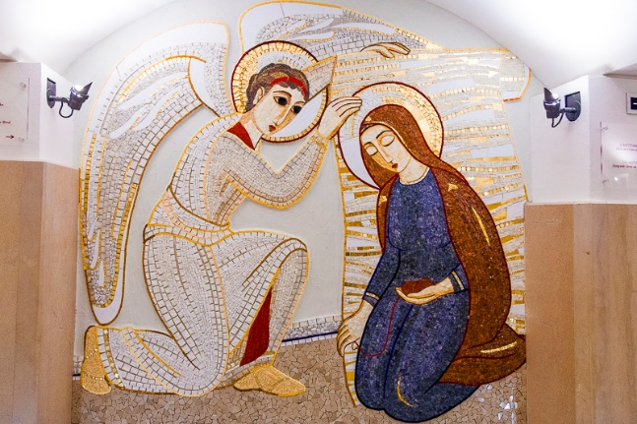
If we allow ourselves to be conquered by God’s love, we understand more and more the importance of holy attitudes which shine in Mary with her attitudes: fiat, stabat and magnificat. By looking at Mary’s life in Luke’s Gospel, we can see her human and spiritual journey which is also our journey. “Nothing to ask, nothing to refuse. Remain in the arms of providence, without falling into any desire other than longing for what God wants of us.”
We will take Mary into our home to make her the cradle of life and love, of faith and of hope by cultivating attitudes of welcoming, hospitality, listening, concrete help and generous availability.
- Union with God in daily life
At the culmination of our journey, we will finally be invited to seek union with God in daily life, assuming His Will: “For me to live is Christ” (Phil 1:21).
We will be able to experience this communion by remaining in Jesus: “I am the Vine, you are the branches” (Jn 15:5).
“Don Bosco identified to the utmost perfection his external activity, indefatigable, absorbing, vast responsibilities with an interior life that began with a sense of the presence of God and which, little by little, became actual, persistent and alive so as to be perfect union with God”. This spirituality becomes Apostolic Charity in ‘Da mihi animas, cetera tolle’. It is the spirituality of the Grace of Unity that helps us to work in harmony of thought, feeling and will with God. Our vertical relationship with God thus inspires our horizontal relationship with our neighbors.
Thus described, we will offer insights and suggestions for the different ages and situations of life: family, youth, adults. We will emphasise prayer, listening to the Holy Spirit and sharing. The suggestion is to live the journey not just intellectually, but also personally and existentially. At the same time, we will take care of the community dimension. The search for a personal relationship with the Lord always leads to communion with others and with the Church. At each session, an appropriate space for silence and a question for sharing in the group will be proposed. Furthermore, to ensure that the fruits of the session can leave their mark on our lives, we will make a concrete life commitment every month.

1. FEEL LOVED BY GOD
Our faith becomes alive when we experience that we are deeply loved by God.
“Then the Pharisees, having heard that he had closed the mouths of the Sadducees, gathered together, and one of them, a doctor of the Law, questioned him to test him: «Teacher, in the Law, what is the great commandment?» He answered him: «You shall love the Lord your God with all your heart, with all your soul and with all your mind. This is the great and first commandment. The second then is similar to that: Thou shalt love thy neighbour as thyself.» On these two commandments depend all the Law and the Prophets ». (Mt 22, 34-40)
We all know that love is the main and the only commandment that Jesus teaches us. The early Christians recognised themselves in the way they loved and in the way they related to one another. It is indeed providential to take up this theme of ‘the LOVE of God and the LOVE of others’ at the beginning of our formation this year. We could not begin in a more evangelical, more fundamental and more Marian way. Let us ask the Lord with faith and conviction, every day of this journey, to help us experience his love as a Father, his unconditional love. It would be important for each of us to repeat every morning, every evening and every moment of the day this profound, intimate and heartfelt prayer: “Lord, help me to experience your paternal love”.
Our faith will remain a theory, a pure theology or only disembodied doctrine if it does not descend atevery moment into our hearts and from there become life. By his incarnation, Jesus wanted to take on our human condition and bring us into relationship with God. It was a choice of love by the Father who from the beginning did not cease to love us and to show us this continuously. This is why I invite you to let yourselves be guided by the Word of God in this month’s formative moment. Read and re-read, but above all pray the text of Matthew 22: 34-40 and ask yourselves: “How do I love the Lord? How do I love others? How can my love grow this year, beginning with my family, my children, my community, my friends and people that the Lord will put along my path?”
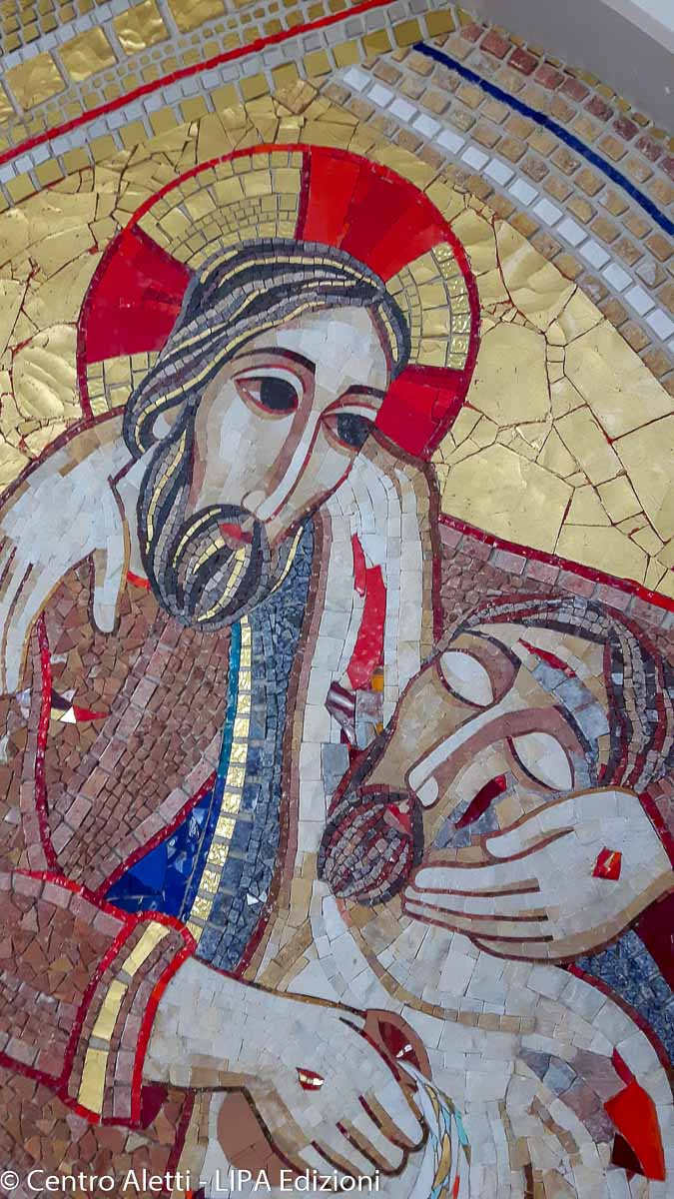
The question «Master, in the Law, what is the great commandment?» posed by a Pharisees to test Jesus becomes the core of the catechesis for his disciples. Perhaps, you too have some questions to ask Jesus and some doubts to clarify, you want to open your heart to him so that he can answer you simply, deeply and gently. Jesus wants to love you completely, entirely. Let Jesus loves you. Open yourself to the Father’s love through the presence of His Spirit. Put yourself in the presence of the Lord, invoking the Holy Spirit with your words so that this encounter may be an encounter of love, to savour Love and learn to LOVE by putting yourself in His presence, following the paths indicated to us by St. Francis de Sales:
- The first is a lively and attentive awareness of God’s omnipresence: God is in everything and everywhere and there is no place or thing in this world that does not manifest His presence.
- The second is to think that God is present not only where you are but also in a special way in your heart and in the depths of your spirit.
- The third is to think of our Saviour, who, in his own humanity, sees from heaven all the people of the earth and especially those who are in prayer.
- The fourth is to think of our Saviour close to us in his humanity, just as our friends are close to us.
1.1. Created by God’s love to love.
God created us because he loves us through his free and disinterested love. This was the first way and sign of God’s love for each one of us: to create us. We were created by LOVE. We are the fruit of God’s Love. God need not have created us. Instead, He gave us the gift of life; He could have pronounced another name. Instead, He wanted to pronounce ours; He could have taken another path, instead, He chose us, He thought of us, He loved us. When a man loves, his heart overflows, and the more he loves, the closer he comes to the heart of God. A heart that loves, shares its joy with others and this is the good wish of its Creator. God created us for an ‘overflow’ of his love. He wanted to share his infinite joy with us so that we would be immensely happy because we are creatures of his love. The true source of joy is love: “The source of Christian joy is the certainty of being loved by God, of being loved personally by our Creator... with a passionate and faithful love, a love that is greater than our infidelity and our sins, with a love that forgives" (Benedict XVI). And the fullest, purest and truest love we will ever experience and receive is God’s love.
We are on earth to know and love God, to do good according to his will, that is, to LOVE and to one day reach Paradise. We are pilgrims of faith because we come from God and go towards God. We have a more remote origin than our parents. We come from God in whom resides all the happiness of heaven and earth, and we are awaited in his eternal and unlimited bliss. Meanwhile we live on earth. Sometimes we experience the nearness of our Creator and at other times we struggle to feel His presence in our lives. For us to find our way home without getting lost, God has sent us His Son who has freed us from sin, saved us from all evil and leads us infallibly to true life. He is “the way, the truth and the life” (Jn 14:6).
God has placed in our hearts the desire to seek him and to find him. St Augustine says: “You have made us for yourself, O Lord, and our heart is restless until it rests in you”. It is natural for human beings to seek God. Our whole search for truth and happiness is ultimately a search for that which sustains us, satisfies us and claims us absolutely. Man is fully himself only when he has found God. “He who seeks truth seeks God, whether he is aware of it or not” (St. Teresa Benedicta of the Cross - Edith Stein).
1.2. God’s love is concrete and sensitive
We all know that God revealed himself because He wanted to be known. God was not obliged to reveal himself to humans but did so out of love. Just as in human love we can only know something of the person we love when he opens his heart to us, we know something of God’s innermost thoughts only because the eternal and mysterious God opened himself to us out of love. From the creation, through the patriarchs and prophets, to the final revelation in the Son Jesus Christ, God has spoken to humanity continuously. In Jesus, he has opened his heart to us and made clear his innermost being for all time. It is up to each of us to recognise that divine revelation is a sign of God’s universal love for humanity in the history of our world. It may be a bit distant for us but our faith helps us to do so. It would be interesting to retrace God’s revelation in the Old Testament by remembering how many signs, pledges and gestures of love he performed with our ancestors in faith.
He called Abraham to make him the ‘father of a multitude of peoples’ (Gen 17:5b) and to bless in him ‘all the families of the earth’ (Gen 12:3b). The people of Israel, born of Abraham, will be his personal property. God makes himself known to Moses by name. His mysterious name, transcribed Yahweh, means “I am” (Ex 3:14). He frees Israel from slavery in Egypt, seals a covenant at Sinai and, through Moses, gives his people the Law. Repeatedly, God sends prophets to call his people to conversion and renewal of the covenant. The prophets announce that God will establish a new and eternal covenant which will bring radical renewal and final redemption. This covenant will be open to all people. Finally, in Jesus Christ, God shows us the fullness of his merciful love. Through Jesus Christ the invisible God becomes visible. He becomes man like us. This shows us the extent of God’s love.
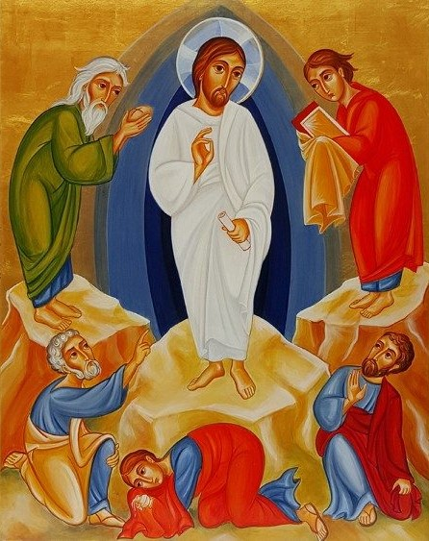
After the revelation in the Old Testament comes the most obvious sign of God’s love: Jesus Christ, his beloved Son. He is the sign par excellence, the greatest manifestation of God’s commitment to man. This is what Jesus wanted to reveal to his friends, especially his closest friends on Mount Tabor. Jesus is the sign; Jesus is the LOVE. The best way the Father found to love us was to give us his beloved Son to love us as the Father loves us.
“At that time, Jesus took Peter, James and John, went up with them alone to a high mountain and was transfigured before them. Their clothes became dazzling white such as no fullness in the world could have left them. Elijah and Moses appeared to them, conversing with Jesus. Then Peter raised his voice and said to Jesus: «Master, it is good for us to be here. We will make three tents, one for you, one for Moses and one for Elijah”» They were frightened and he did not know what he was saying. A cloud formed and covered them, and out of the cloud came a voice: «This is my beloved Son, listen to him!»”. (Mk 9:2-8)
It is our task to discover in Jesus the Son, the love of the Father through faith. The Father has sought to manifest his love in a perceptible way for us and has found no better way than Jesus, his Son. Let us ask ourselves: Is Jesus a sign of LOVE for me? Do I feel loved in Jesus? Do I feel the love of Jesus in my life?
It is true that Jesus does not love us bodily, like a father, a mother, a friend... his presence is not as tangible as that of an ordinary human being. But it does not mean that his love does not exist, is not true and is not deep. He loves us every day in his Word, in the Eucharist, in Reconciliation, in the people he gives us, in the depths of our hearts when we understand what we were created for.
Faced with this love that God has for us, we must be amazed, contemplated... let God love us so that it becomes a source of service and love for others. When we powerfully experience the Father’s love in our lives, it impels us to reciprocate His love with love for others. In the words of St. Paul, “the love of Christ urges us.” The first commandment to love God finds its fulfilment in the commandment to love our neighbours. Through our faith, we love God in others. That is why our faith is a response to love and at the same time it is God’s love in the service of others.
1.3.- Faith is the response to God’s love.
Whoever wants to believe needs “an attentive heart” (1 Kings 3:9). God tries in many ways to make contact with us. In every human encounter, in every moving experience in nature, in every apparent case, in every challenge, in every pain, a message from God for us is hidden. He speaks to us even more clearly when he addresses us with his word or with the voice of our conscience. He speaks to us as a friend. Therefore, we must also respond to him as friends and believe in him, believe in him completely, learn to understand him better and better and accept his will without reservation.
Faith is knowledge and trust; faith is a pure gift from God, which we receive if we ask for it ardently; it is the supernatural power needed to achieve salvation; it requires the free will and clear understanding of man when we accept the divine invitation; it is absolutely certain because it has the guarantee of Jesus; it is incomplete until it is effective in love; it increases if we listen more attentively to God’s voice and through prayer experience a living encounter with Him. Faith already allows us to taste the joy of heaven in advance.
This faith enables us to love and it increases the love more and more. Only when we believe can we love without expecting anything in return. Only when faith sustains our love can we heartily forgive those who have offended us.
For personal prayer and meditation
1.- Meditate on these sentences and pray.
- The measure of love is love without measure. (St. Francis de Sales).
- Love is joy in the face of good; good is the only foundation of love. To love means: to want to do good to someone. (St. Thomas Aquinas)
2.- What do you want to do in order to welcome God’s love and perceive it in your daily life?
3.- How can you cherish God’s love during this year? How to love Him and feel loved by Him?
Monthly commitment
Pray and insistently ask the Lord every day... “Lord, help me to experience your love – the love of an endearing Father towards his child”

2. HERE I AM AT YOUR DOOR AND KNOCK

“Therefore, behold, I will draw her to me, I will lead her into the wilderness and I will speak to her heart.” (Hosea 2,16)
God is a dialogue of love and calls us to dialogue with Him.
To pray is to enter into this dialogue with God who seeks us and desires to be with each one of us.
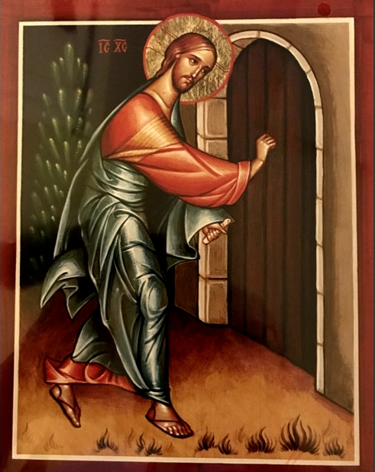
“Prayer is a conversation, a dialogue, a conversation of the soul with God. Through it, we speak to God and reciprocally God speaks to us; we aspire for Him and breathe in Him and reciprocally He inspires in us and breathes on us.” (Theodotion VI, 1).
“Behold: I stand at the door and knock. If anyone hears my voice and opens the door for me, I will come to him and dine with him and he with me.” Rev (3:20)
To pray is to keep the door of our heart open. As Pope Francis says
“God is the friend and the bridegroom. In prayer we can establish a relationship of trust with Him, so much so that in the ‘Our Father’ Jesus taught us to express to Him a series of needs. We can ask God anything, everything; explain everything, tell everything. It does not matter if we feel at fault in our relationship with God: not good friends, not grateful children, not faithful spouses. He continues to love us. This is what Jesus demonstrates definitively at the Last Supper when he says: «This cup is the new covenant in my blood, which is poured out for you.» (Lk 22:20). In that gesture, Jesus anticipates in the cenacle the mystery of the Cross. God is a faithful friend: even if human beings stop loving, He continues to love, even if that love leads Him to Calvary. God is always near the door of our heart and waits for us to open it. And sometimes He knocks on the heart but is not compelling: He waits. God’s patience with us is the patience of a father, of one who loves us so much. I would say, it is the patience of a father and a mother at the same time, always close to our heart. When he knocks, he does it with tenderness and with much love.”
“I have told you these things while I am still with you. But the Paraclete, the Holy Spirit, whom the Father will send in my name, will teach you all things and bring to your remembrance all that I have said to you.” (Mt 16, 25-26)
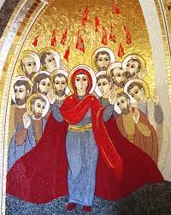
The protagonist of prayer is the Holy Spirit, the Spirit of the Lord Jesus, who wishes to live and walk with us every day, to enter and inhabit our heart.
As in the parable of the merciful father, God continually gazes into our hearts from afar, always longing to see us return to Him, even with a single nod.
Prayer is first of all openness to this gaze, to this relationship, to the gift that God wants to give us of His Love, so that we can perceive it, encounter it, feel loved by Him and reciprocate this love in our daily lives.
“If anyone loves me, he will keep my word, and my Father will love him, and we will come to him and make our abode with him.” (Jn 14, 23)
By speaking to us through His Son (Word), God enables us to speak to Him as children (prayer).
Prayer is, therefore, listening to the Word of the Lord which is given to us in order to enter into full communion and union with Him. If we entrust ourselves to the Word, we will be transformed by it little by little, because it is efficacious and does what it says. The Word must be welcomed not only as a teaching that can enlighten our minds but also as a seed that mysteriously makes the life of Jesus germinate in our hearts. He is the ‘Sower’ and we are invited to be “those who, having heard the Word with a whole and good heart, keep it and bear fruit with perseverance.” (Lk, 8-15)
“At that time, as a large crowd gathered and people from every city flocked to him, Jesus said in a parable, «The sower went out to sow his seed. As he sowed, one part fell by the wayside and was trodden down, and the birds of the air ate it. Another part fell on the stone and, as soon as it sprouted, dried up for lack of moisture. Another part fell among the thorns and the thorns which grew together with it, choked it. Another part fell on the good soil, sprouted and yielded a hundred times as much.» Having said this, he exclaimed, «He who has ears to hear, let him hear!»
His disciples questioned him about the meaning of the parable. And he said: «To you it is given to know the mysteries of the kingdom of God; but to others only in parables, because by seeing they may not see and by hearing they may not understand.»”
The meaning of the parable is this: the seed is the word of God. The seeds that fall by the wayside are those who have heard it, but then the devil comes and takes the Word away from their hearts, lest by believing they should be saved. Those on the rock are those who, when they hear, receive the Word with joy but have no roots; they believe for a time, but in the time of trial they fail. The one fallen among the thorns are those who, after hearing, on the way let themselves be suffocated by the cares, riches and pleasures of life and do not fructify. The one on the good ground are those who, after listening to the Word with a full and good heart, keep it and bear fruit with perseverance.
“I particularly recommend mental prayer that engages the heart to meditate on the life and passion of the Lord. If you contemplate Him often in meditation, your heart and soul will be filled with Him; if you consider His way of acting, you will take His actions as a model for your own. He is the light of the world: it is therefore in Him, by Him and through Him that we can be enlightened and find clarity. Believe me, we can reach the Father only through this door.” (Philothea II:1)
Prayer aims at union with God and the fulfilment of His will. It gives us the right sense of our wretchedness as creatures and our greatness as children of God. It makes us capable of discerning by reading reality and history with God’s eyes. It makes us grow in the attitudes of faith, hope and charity.
“There is nothing that purifies our intellect so much from its ignorances and our will from its evil affections as prayer which introduces our mind into divine clarity and light and exposes our will to the warmth of heavenly love; it is the water of blessing, which, sprinkling us, makes the plants of our good desires green and blossom again, washes our souls of their imperfections and extinguishes the passions in our hearts” (Philothea II, 1-2).
“Let us all try to pray in this way, entering into the mystery of the Covenant, to place ourselves in prayer in the merciful arms of God, to feel wrapped in that mystery of happiness that is the life of the Trinity, to feel like guests who did not deserve such honour and to repeat to God, in the amazement of prayer: is it possible that You know only love? He does not know hatred. He is hated but He does not know hatred. He knows only love. This is the God to whom we pray. This is the glowing core of every Christian prayer. The God of love, our Father, who waits for us and accompanies us.” (Pope Francis)
In this journey, the best guide is Mary. She knew how to be the good soil of the Word whom she welcomed with her FIAT and generated not only in her heart but also in her flesh.
Learning to pray
St. Francis de Sales invites us first of all to prepare the heart:
I would like to remind you of the preparation which consists of the following points:
I propose four ways to help you put yourself in the presence of God. Do not pretend to use them all at once. Choose the one that suits you best, simply and briefly.
- The first is a lively and careful awareness that God is in everything and everywhere and there is no place or thing that does not manifest his presence. Although we know this, we often do not think about it and it is therefore as if we did not know. That is why, before prayer, say to your heart with deep conviction: “My heart, God is right here!”
- The second way is to think that He is not only present in the place where you are but He is particularly present in the depths of your heart. And your heart is His privileged and special home!
- The third way is to think of our Saviour who, in His humanity, from heaven with His gaze continuously follows all people on earth.
- The fourth way is to imagine the Saviour close to us, just as we want to be with friends. If you are then in a place where the Blessed Sacrament is, this presence is real: He is really present there. He sees you and thinks of you (Philothea II:1-2).
The second step is to approach the Word.
“I take the chosen passages for prayer. I renew within me the consciousness that this Word is full of the Holy Spirit and I begin to read it with an attitude of respect and basic interest in it. I read and reread the text until my inner attention lingers more on certain words, drawing from them a certain flavour, a warmth, or until I perceive that certain words begin to relate more vividly to me. Or when I understand certain words as particularly important for me, for my situation, for our church community or even for present context. Then I dwell on them and begin to repeat them in a low voice, with attention to my heart and my relationship to this Word, that is, a Person speaking to me. In this way, as I repeat these sacred words for several minutes, perhaps with my eyes closed, I am not so much attentive to their meaning as to who they are, what they are full of and where they are meant to take me. It is the Word of God that arouses in me a veneration, a fear, a respect. As Origen taught, it is the Word imbued with the Holy Spirit. When I listen to the Word, repeat it or simply pay attention to it, it is the Holy Spirit acting in me. The relationship that is established with the Word is realised by the Holy Spirit and is in Him. It is the Spirit who opens me to the attitude necessary for the Word to speak to me. Since the Word is a living Person, I do not need to attack it with my own in order to know it. I can also interrupt the repetition of the Word to tell the Lord some reflection or feeling of mine that I am experiencing at that moment. The important thing is that all the time I keep this formula of speaking, thinking, praying to a Thou, that is, maintain an attitude of relationship with God. I must not be afraid to tell, at the beginning perhaps even in a low voice, my reflections, questions, thanks, supplications to the Lord, calling him by name” (Rupnik - The Discernment).
The third step is to identify the good resolutions that prayer has aroused in us
“Coming out of meditation, Philothea, you must take with you above all the resolutions and decisions you have made, to put them into practice immediately during the day. This is the indispensable fruit of meditation. As you leave the prayer that has engaged your heart, you must be careful not to shake it; you would risk spilling the balm you have gathered in prayer. I mean to say that, if possible, you should remain silent for a while and gradually bring your heart back to consciousness, preserving as long as possible the feelings and affections that have blossomed within you.”

For personal prayer and meditation
- Is your prayer a silent listening to the Word of God?
- Does this listening become a true and personal dialogue with the Lord?
- Do you let Mary accompany you in prayer to be a good soil?

Monthly commitment
Devote time to prayer with the Word of God

3. CHILDREN CREATED IN THE IMAGE OF GOD. TRUST IN GOD.
We surrender ourselves to the Holy Spirit, accompanied by Mary and imitating her: this leads us to grow in trust in God.
What does it mean to trust in God? It seems a very simple thing and in a way, it is; but it is not so ‘natural’. Everyone who is going through life as an adult, in its various stages, has experienced the temptation and probably the reality of wanting to be ‘self-sufficient’. In itself, this is good, but it becomes bad when, at the end of the day, ‘self-sufficiency’ means that I want to be the one to guide my life, in the sense that I am convinced that I am the one who knows best what is good for me.
In this sense, Pope Francis reminded us that it is important to do what Naaman, the Syrian, did when he wanted to recover from leprosy. He had to accept to take off his grand and sumptuous robes he wore to go and bathe in the Jordan, like everyone else. Naaman had to trust the prophet Elisha and put aside his pride and put on humility. So also, the Samaritan leper was able to turn back and thank Jesus. Lord Jesus is more important than everything, even the healing itself and the fulfilment of the rules! (cf. Francis, Homily for the canonisation of St. John Baptist Scalabrini and St. Artemis Zatti, 9 October 2022).
Trust in God, then, could be described as the deep (and growing) conviction that it is God who knows - better than me! - what is good for me. This is very easy to say or write, but not at all easy to live. It would suffice to examine a few examples of my prayer of request. What do I normally ask God for me? For example, when I do not feel well, I ask for health for me “to continue to serve him with joy”. It is alright. But have I stopped for a moment to ask myself whether having good health, at this moment, is really the absolute best for me? It certainly is from a human point of view but is it also from the only point of view that matters - that of the Father?
When a loved one is seriously ill, we pray that he or she may regain health. But what if the only way for that person to be truly and totally in God’s embrace is to go through that illness - and die of it? If I knew this, would I still pray for that loved one’s health? Or would I not rather pray for the fulfilment of the Father’s dream for him/her, come what may? Because the most important thing is not to have health or sickness, but to reach, at the end of the earthly experience, the Father’s embrace. If I truly trust in God, my perspective changes. This does not mean that I stop praying for the needs of my life and the lives of my loved ones and the world, but that I learn to add to each request prayer a thought such as: ‘if this is your dream, Father...’; ‘if this is your will...’; ‘I pray for N.N. to get well, if it will help him to reach you forever...’ or similar prayers. A prayer of request without this very important ‘addition’, after all, is a bit like going to the Father like to a selling machine, not of drinks, but of graces! If we consider that prayer is like the coin I insert, when we do not get the grace, we may feel that the selling machine has ‘stolen’ my coin! This is not the God of Jesus Christ!
“Ah, then, this God is a cruel God!” Not at all! He is a God who puts himself at stake, because, in Jesus his Son, on the cross, the Father is close to all those who suffer and who are in difficulty, in ways that we human beings cannot even imagine. However, it takes a profound attitude of reliance and this is difficult in the perspective of self-sufficiency. Indeed, it often becomes ‘self-reliance’ or ‘selfishness’!
That is why Jesus asks us to become children!
In Matthew 18:2-4, the evangelist puts those very famous words on Jesus’ lips: “Then he called a little child to himself and set him in the midst of them, and said, ‘Truly I say to you, unless you change and become like children, you will not enter the kingdom of heaven. Therefore, whoever will become as little as this child, he is the greatest in the kingdom of heaven...”.
It is a matter of ‘becoming’ children and not ‘remaining’ or even strictly speaking ‘becoming’ children again. Becoming indicates a lifelong process of growth - like any true spiritual process. Only an adult who entrusts himself to the Father, through Jesus, in the Holy Spirit, can ‘become’ a child... and the main characteristic of a child is that he trusts Daddy and Mummy. He is so certain of their love for him that he does not need anything else: neither power, nor position, nor recognition, nor ‘self-sufficiency’. Living like a child in a world of cut-throat competition is not easy. We must be adults while maintaining the heart of a child, a heart that rests in God, that surrenders to God. He will know how to be our defender. He is our Father, He is faithful. We often fret instead of trusting in the Lord (editor’s note: adapted from words by the writer Jacques Philippe).
A friend once recalled an adventure he had as a child. He must have been 5 or 6 years old and his family went for a walk in the mountains: it was a beautiful day and very tiring. On the path back to the place where they had left the car, he was feeling very tired. He also remembers his father taking him in one hand and his mother in the other and off down the path. He no longer knew whether he was walking or flying... They arrived at the car ‘safe and sound’; he settled into the back seat and fell into a deep sleep all the way home. Many years after the event, my friend still used that image to describe what it is to trust in God: it is like walking on a mountain path with confidence, because daddy and mummy’s hands hold me and will never allow me to fall and hurt myself... A childish image? On the contrary: a powerful image in its simplicity, for us adults who would like to do everything ourselves and tend to turn to the Father only when we are in trouble.
The source of this style of trust, the model, is Jesus himself. In the Letter to the Hebrews, the sacred author puts these words on Jesus’ lips:
“Therefore, entering the world, Christ says: ‘You wanted neither sacrifice nor offering, a body instead you prepared for me. Thou hast pleased neither holocausts nor sacrifices for sin.’ Then I said, ‘Behold, I come - for of me it is written in the scroll of the book - to do, O God, thy will.’ ” (Heb 10:5-7)
This is the context in which Scripture invites us to read the whole mystery of the Incarnation (cf. Luke 2), which is a very profound mystery of trust of the Son in the Father and of the Father in the Son. Jesus comes into the world not because he ‘likes it’ in a particular way, not to fulfil himself as a person, nor even to show us how good he is, but to do the Father’s will. This is the basis of the attitude of trust that will reach the highest level in Gethsemane (cf. Lk 22:42: “Father, if you will, remove this cup from me! Yet not my will but Thy will be done.”) and on the cross (cf. Lk 23:46: “Father, into Thy hands I commend my spirit.”).
Of course, once again, we see that this is an attitude that needs a long time to become second nature to us... It is important not to be discouraged if we see that we are still so far from this ideal.
If we take all this as a background to the Incarnation narrative in Luke 2, perhaps we can grasp the sense of development and fulfilment that we read between the lines in that chapter of the third gospel. Who knows why the census happens - and Joseph and Mary’s journey accordingly - just as Mary is pregnant and about to give birth? Could not a better time have been chosen? Could they not have found a place in an inn? Oh yes, it was a full house because of the census... And the first witnesses? Could it be that they had to be shepherds - not very recommendable people according to the mentality of the time (they were always with the animals and then worked at night, like thieves...)?
Mind you, twice in this chapter of Luke a remark about Mary is repeated: in v. 19 and then in v. 51b - “Mary, for her part, kept all these things, pondering them in her heart”. Here there is an important indication that comes to us precisely from Mary, the teacher, in becoming like a child: meditation, silent prayer. The mystery of Christ’s obedience can only be approached in this way: with prayer.
Mary, in turn, shows us how to accept God’s will. At the end of the story of the Annunciation, Mary comes out with that striking statement: “Behold the handmaid of the Lord: let it be to me according to your word” (Lk 1:38). What she understood, at that point, of all that was to happen to her was unclear. Certainly, it was not much.
How many questions must have passed through her mind and heart at that moment... And how many more during the journey of daily life, especially during the 30 years in Nazareth, when she must have asked herself: “Is this really the Son of God?” This child of mine who laughs and cries, who sleeps and eats, who falls and hurts his knees...? This boy whose eyes reflect the clarity of heaven but who does nothing special at all? Does he study like everyone else at the synagogue and learn his father’s trade? This young man who evidently has a big heart and loves everyone but does not seem interested in any girl of his age? What will become of him? What will become of that promise, almost thirty years ago?”
Yet, Mary trusted and let God’s hand hold her through the journey of a lifetime. There were certainly many dark moments but Mary decided never to abandon the hand that she grasped the day she said her ‘yes’ – ‘the fiat’. And to do so, she chose the attitude of meditation and silent prayer.
One of the most privileged avenues of God’s revelation - as he is - is precisely the mystery of the Virgin Mary. It is beautiful to see how Mary is present in the life of the world today. If we entrust ourselves to her, if we allow ourselves to be guided by her, she gives us access to true knowledge of God, because she introduces us into the depths of prayer and authentic trust. If we place ourselves totally in her hands, she educates us and communicates to us the true knowledge of God (editor’s note: adapted from words by the writer Jacques Philippe).
In the light of the Strenna 2022 which invited us to rediscover the figure of St. Francis de Sales on the 400th anniversary of his death, it seems to me that we can find some interesting insights precisely on obedience and trust in God. The very title of the Strenna is taken from a letter of Francis to Joan Frances of Chantal. The precise point reads:
“If you are very fond of the prayers you have indicated above, do not change; I beg you and if you seem to be giving up something I propose, do not have any scruples because the rule of our obedience, which I write to you in large letters, is: DO EVERYTHING FOR LOVE, NOTHING FOR STRESS; IT IS BETTER TO LOVE OBEDIENCE THAN TO FEAR DISOBEDIENCE.” (Letter CCXXXIV. To the Baroness of Chantal, 14/10/1604, OEA XII, 359)
‘It is better to love obedience than to fear disobedience’. These words give us a glimpse into Francis de Sales’ approach to the subject of obedience. It only works in a context of total love and trust and cannot be based on the fear of doing wrong. It would be a bit like deciding to stop running or even walking because we might fall!
To do this, Francis de Sales suggests the very important path of prayer, as communication from the heart of man speaking to the heart of God. That God who is not only God of the human heart but also ‘friend of the human heart’. Therefore, through this type of prayer, it is a matter of loving God’s will, of making the beating of our heart coincide with that of the Master... since prayer is not thinking much but loving much... (cf. Á. Fernández Artime, “Do everything out of love, nothing by force” Strenna 2022 - pp. 22-23).

For personal prayer and meditation
- In what areas of my life do I tend to be more ‘self-sufficient’ or even ‘self-referential’ and how do I combine this with my relationship with God?
- How do I conceive of my prayer request? According to what parameters? And is it really done in the light of God’s plan or only my own? Can I still discover moments in me when I address the Father as a ‘selling machine’ of graces?
- At what point am I on my journey of becoming a child? How do I grasp the hand of God that holds me and how do I cling to it?
- Do I try to imitate Jesus, basing my trust on my choice of obedience to the Father’s will? How?
- Do I reflect on Mary’s human journey of faith, from the ‘fiat’ to Pentecost?
- Do I love obedience rather than fear disobedience? Am I tempted, at times, to stop walking in order not to fall?
- Is my personal prayer made of silence, increasingly becoming an experience of my heart speaking to the heart of God? Or is there still a lot of ‘noise’ and too much of me, too little of Him?

Monthly commitment
Add to each prayer request, we will add a thought such as: “if this is your plan, Father...” “if this is your will...”

4. "HE LOVED THEM TILL THE END" (Jn 13,1)
1. To recognize at the heart of the present
“Keep on winning well in those little daily contradictions that trouble you, and direct the best of your desires to this. Know that, for now, God wants nothing more from you than this; and therefore, do not waste your time wanting to do anything else. Sow not your desires in another’s garden, but take care only to cultivate your own well. Do not desire to be what you are not, but desire to be in the best way what you are. Direct your thoughts to perfect yourself in this and to bear the crosses, great or small, that you will find in the place you have been assigned. And believe me: this is the great secret and the least understood secret of the spiritual life. Everyone loves what is to his taste, and few love what is in accordance with their duty and the taste of our Lord. What is the use of building castles in Spain, if we have to live in France? This is an old lesson of mine, and you understand it well.” (Letter to President Brulart’s wife, June 1607)
Choose a present to love or choose to love the present? We could summarise in these words the question Francis de Sales addresses to one of his Philalethes in a letter of 1607. In fact, echoing from century to century, the question posed by the saintly bishop of Geneva comes down to us, forcefully addressing our hearts particularly during this Advent season that prepares us for the Lord’s Christmas.
The sharp words of Francis de Sales reveal to us at the same time the deepest secret of holiness and help us to unmask one of the most frequent and insidious temptations that often lurks in our path. The saint of loving-kindness, with a tone that is at once delicate and decisive, lets us clearly understand that the only garden in which the seed of holiness, sown by God’s grace and guarded by our freedom, can grow, blossom and mature is one and only that of our present, of the here and now. It is the here and now of our time and space, of our living conditions and health, of our ties and affections, of our work and the thousand circumstances of daily life, of our smallness and our faith always on the move. It is a present that sometimes seems cramped and at other times reveals incredible surprises, a present that is always imperfect and undermined by the passing of the days, a present that is, however, the only true, concrete and real time of our life, the time in which our life is at stake. It is not always immediately evident, recognisable and visible on the surface that the presence of God represents the true and authentic wealth that our present holds. It is, in fact, a wealth that is both profound and precious. It does not impose itself and does not seek spaces of prominence, but in a discreet and concrete manner, tenaciously chooses not to withdraw but to continue to inhabit and bless this time, not transforming it into another time but transfiguring it, for what it is, into a time of grace.
Francis de Sales knows this very well. He knows very well that if we do not recognise God’s visitation in today’s events, we will hardly recognise it in tomorrow’s events because tomorrow when it arrives, will also be called today. At the same time, the Savoyard saint knows very well the temptation to escape from the present which, in one way or another, knocks at the door of our heart. It is the suggestive temptation not to live in the here and now, to surrender in the face of the apparent monotony, aridity and sterility of everyday life, in order to look elsewhere and otherwise for a more promising garden, more suitable to host and welcome our journey of holiness. Varied and colourful can be these destinations of our flight elsewhere. Sometimes we take refuge in the past, idealising and regretting the beauty, often idealised, of a time that is no more. At other times, we lean towards an imagined and imaginary future, dreaming of it without those harshness and imperfections that instead accompany us in the present. At other times still, we long to seek refuge or escape into a different present, real or virtual, where it seems to us that conditions, situations and circumstances are much more conducive to our journey of following the Lord. Faced with these temptations that he knows very well, the Bishop of Geneva points us with mild resolve to our present, lived without discounts or loopholes, as the only real and concrete space in which it is possible to meet the Lord, the only place that the Lord chooses and in which he does not cease to visit and bless our lives. Being in the present is certainly not easy, and recognising the present as the place where the Lord comes to meet us obviously does not mean petrifying existing reality into a cold and glacial stillness, in which nothing changes and nothing mutates. The secret that the holy bishop delivers to us is much deeper and more precious.
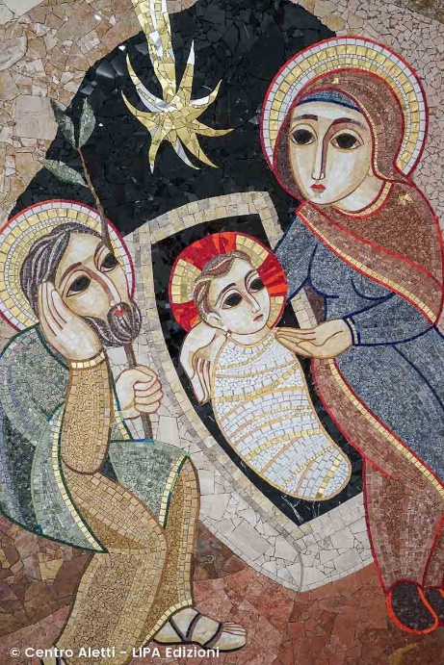
Francis de Sales suggests that it will never be possible for us to meet the Lord elsewhere that may be perfect but is certainly abstract and unreal but it is possible only in this present, as it is, in its lights and shadows, in its chiaroscuro and even in its contradictions. It will never be possible to meet the Lord if we do not recognise Him in the folds and wounds of reality, in the garden of our life and our history, in that France which, while seeing the thousand advantages and merits of a hypothetical Spain, is the only true ground of our life. Only in this way will it be possible to experience that the Lord does not come to meet us because we inhabit a present made perfect by our own efforts, but meets us, where we are, because He infinitely and simply loves our life.
The Lord does not ask us to be other than what we are or to go elsewhere than where we are but rather asks us for the humility to welcome His coming in the poverty of this present which, like the manger of Bethlehem, is the only place where God asks us to be housed. And it is precisely from this experience, from having recognised in the Lord the guest, often unnoticed in our daily life that we receive the strength to walk and grow in holiness. Holiness therefore is not, as we often think, to replace this present with our life and our history, with another present, radically new and totally different, which erases in an instant, as if with a stroke of a sponge, what we are and what we have been, to make room for a new beginning that presages better possibilities of success by starting again from scratch. Holiness is not even, by dint of our will and our efforts, trying to make progress, to grow and to improve, as if God, after having given us a path to follow, were waiting for us at the finishing line, interested and intrigued to assess the effectiveness of our efforts and the resilience of our perseverance, as if somehow, we had to deserve and earn His love by dint of our efforts and achievements.
The secret of holiness that Francis de Sales reveals to us is actually something infinitely more beautiful and greater, something infinitely more divine and immensely more human. Holiness is not attempting, by force of will, not to be what we are and to be other than what we are, denying what God has willed, blessed and loved our unrepeatable uniqueness. Holiness, on the other hand, is precisely living this present. It is, striving to be what we are in a perfect way, not as the goal of our efforts, but in the light of discovering and recognising ourselves, with infinite and never exhausted wonder, privileged recipients of God’s eternal, infinite and faithful Love that knows no hesitations or second thoughts, to the point of giving His very life for us. It is precisely this knowing that we are gratuitously and infinitely loved by God, called to respond and not to chase after His Love, that allows our life to flourish in true and authentic holiness, in reflecting, in a unique and unrepeatable way, in a way that is and will be ours alone, in the features of our face the features of the Lord’s face. The Love of God, His presence beside us, His dwelling in this very daily life, does not magically transfer us to a different present, but radically transforms and transfigures this present, renewing it, making it flourish and bear fruit in all its potential and possibilities for goodness, light and joy. In our lives and in our present, as Francis de Sales clearly shows us, if we have the courage to inhabit it and dig it out, we will discover that God does not discard but redeems, does not condemn but purifies, does not give suggestions but loves. And this is precisely the secret of holiness. Not having to make an effort to blossom in order to be loved but being able to blossom thanks to the fact that we have already been loved infinitely, without ifs and buts, not sent back to the sender because of our faults, often the result of the wrong choices of our freedom, but redeemed and radically renewed by the greater Love that has loved us to the end, that is, to death and death on a cross. Holiness is not to be other than ourselves, but to become, through the daily weaving of grace and freedom, fully ourselves, what we are called to be, that is, not as we dream ourselves, but as from eternity God has dreamed and does not stop dreaming of us. All this cannot be experienced elsewhere but only at the centre and heart of this present, inhabited, animated and loved by God.
2. ... the loving presence of God...
From the Gospel of John (John 13: 1-17):
Before the feast of Easter Jesus, knowing that his hour had come to pass from this world to the Father, having loved his own who were in the world, he loved them to the end. During the supper, when the devil had already put it into the heart of Judas, son of Simon Iscariot, to betray him, Jesus, knowing that the Father had given him everything in his hands and that he had come from God and was returning to God, got up from the table, laid down his clothes, took a towel and wrapped it around his waist. Then he poured water into the basin and began to wash the disciples’ feet and to dry them with the towel with which he had girded himself. Then he came to Simon Peter and the latter said to him, “Lord, do you wash my feet?” Jesus answered, “What I do, you do not understand now; you will understand later.” Peter said to him, “You will not wash my feet for ever!” Jesus answered him, “If I do not wash you, you will have no part with me.” Simon Peter said to him, “Lord, not only my feet, but also my hands and my head!” Jesus added: “He who has bathed, has no need to wash except his feet and is all pure; and you are pure, but not all. For he knew who would betray him; therefore he said, ‘Not all of you are pure.’ When he had washed their feet, he took his garments, sat down again, and said to them, “Do you understand what I have done for you? You call me the Master and the Lord and you are right, for I am. If therefore I, the Lord and the Master, have washed your feet, you also must wash one another’s feet. For I have given you an example, that ye also should do as I have done unto you. Truly, truly, I say unto you, a servant is not greater than his master, nor one who is sent greater than he who sent him. Knowing these things, you are blessed if you put them into practice.
It is the presence of God at the heart of our present that makes our present, even in its inevitable and unpredictable imperfections, the place where our holiness is called to flourish. God’s presence at the heart of our present gives us the grace and strength to be present to our present, living it in the presence of the One who, eternally present, loves us and constantly accompanies us with His Love in our daily lives. It is God’s choice to inhabit our time that makes our time habitable, a place where it is possible to receive, recognise and give back His Love. In this journey of ours which, by leading us to inhabit our present, helps us to escape the ever-lurking temptation to seek refuge elsewhere, a privileged time is certainly that of Advent.
Advent is the liturgical season that the Church offers us every year to prepare ourselves, walking in communion and community, for the mystery of the Lord’s holy Christmas. Advent is an absolutely special time of grace, a time that is given to us so that we can renew our awe and reawaken our wonder at the most shocking and unpredictable event of all time, an event that has changed history forever. A philosopher of antiquity stated with unshakeable certainty: “One thing is certain. No other god ever came down here!”. Faced with this affirmation that categorically excludes that God can in any way come close and make Himself present to the present of mankind, there arises the unexpected and unprecedented mystery of Bethlehem that the evangelist John condenses in these words that from age to age never cease to echo in history: “the Word became flesh and pitched His tent among us” (Jn 1:14).
In the cave of Bethlehem, God, by His free choice of Love, does not remain far and distant. He does not send man a messenger or a code of behaviour but becomes man by being born of the blessed and ever virgin Mary. At Christmas, God the Father sends His only-begotten Son into the world by the power of the Holy Spirit, not to condemn the world but to save the world in His Love. This is the mystery of the Incarnation that we are preparing to celebrate at Christmas, the mystery of the Love of God who, in order to save mankind. He does not hesitate to involve Himself personally in human history, crossing the boundaries of the eternal and coming to dwell in the heart of time, of history, of the present of every man. It is in Christmas that the Son of God, of the same substance as the Father, comes to dwell in the heart of our present, so that every man, at the heart of his present, may encounter the wide-open heart of God. In Christmas, God, by becoming man, does not decide to recreate from nothing “another present”, but chooses to renew and recreate our present with His Love, which overcomes all distance, loneliness and abandonment. With the Incarnation, the Eternal for Love of man becomes ‘nomadic’, accepting to come and dwell among us, pitching His tent in our time, so that each one of us along our own path can discover and experience that we are constantly and daily accompanied by Emmanuel, the God-with-us.
It is this same Love that brings God to become man in Christmas, that is manifested and fulfilled definitively in the Easter of the Lord’s death and resurrection, in His giving His life ‘for us and for all’, for the salvation of every man. In the mystery of Christmas and Easter, events that perhaps seem so different and distant to us at first sight, the same logic of Love pulsates and the same infinite and boundless Love of God for man lives. It is precisely on the cross that God’s Love is unveiled and revealed in all its incredible and infinite depth. It is a Love that loves to the end, without discount and without second thoughts. It is the Love that chooses to inhabit the last place, the place of the one abandoned by God, so that no man, even the most distant, far and desperate, will find himself excluded from this embrace of salvation that is forever wide open to the heart of the world. After Easter, there has never been and never will be, until the end of time and history, a present in which God is not present, a present in which, if we accept to welcome the gift of Love that is always offered to us, we cannot touch with our own hands that God loves us and saves us. It is precisely for this reason that God’s Love might also be present at the heart of our present to the end, that the Lord, on the night when He was betrayed, gave us and handed over the Eucharist, the perennial sacrament of His Love for us. It is precisely for this reason that the Eucharist is the greatest treasure God has entrusted to His Church, the source and beating heart of the life of the Christian community and the journey of every child of God. In the Eucharist, the gift of Love experienced by the Lord on the cross does not remain a memory locked in an ever distant past but in the power of the Holy Spirit, it becomes present at the heart of our present, reaching out to our lives in the here and now of our time. In the ‘daily bread’ of the Eucharist, broken day after day for our salvation, the Lord’s cross, the sacrifice of God who sacrificed himself for our salvation, crosses and breaks the boundaries of time, becoming a living source of Love that we can draw upon in our present. The Eucharist is the place where we discover who we are in God’s eyes, beloved children for whom the Father did not hesitate to sacrifice His only Son, so that no one might be lost and all might be saved. The same sacrifice, the same cross, the same infinite Love in the Eucharist is made present in this time and in this space so that, to the ends of the world and of time, every man can experience and receive God’s salvation. It is the Eucharist that, by making present the cross of the Lord and planting it at the heart of our present, gives us the grace to be able to inhabit and live this present of ours, without shying away to elsewhere, as a time of grace, in which to recognise and encounter the face of God. Then we understand the words of a Church father who, comparing Christ to the beloved of whom the Song of Songs speaks, saw in the Incarnation, the Cross and the Eucharist the three ‘leaps of Love’ with which God in His Son chose to make Himself present in the present of every man. It is the words of the evangelist John that allow us then to gather, even in our poverty, four sparks of this infinite Love that we are called to receive every day in the Eucharist. As we know, John, unlike the synoptics, in recounting the Lord’s Last Supper does not narrate the institution of the Eucharist, but gives us the scene of the washing of the feet in which the Master and the Lord, on the night in which He was betrayed, loved His own to the end, stooping to wash their feet. It is this gesture, forever impressed in the pages of John and in the heart of history, that reveals to us the profound meaning of the Eucharist, of which the washing of the feet constitutes the ‘explanation’ that the Lord Himself offered us.
a. The gift of presence. In the Eucharist, the Lord today, here and now, makes himself present at the heart of our present, not elsewhere. In it, God does not give us advice or directions but chooses to show us His Love in the most radical and profound way there is, that is, with the language of presence. To love is to become present and to be present and it is precisely here that Salesian spirit is rooted. God is not content to tell us or give us something but in the Eucharist, he chooses to come, with all of himself, to inhabit this present time, not another time. Presence, the sharing of time, is the basis and foundation of all Love. With the Eucharist, God does not choose to inhabit our past or our future but makes the here and now, at times so harsh and arid, the privileged time in which He meets, loves and saves our lives.
b. Sacrifice. God’s presence in our present is not a distracted, indifferent, curious present. It is not a touch-and-go. In the Eucharist, God does not come to take a look at our present. He does not appear at the window of my history for a quick inspection of the building site of my life but bursts into my life with all the charge and empowering force of His Love that did not hesitate to sacrifice Himself for me, to the end, to my last breath. The presence of God that the Eucharist unleashes at the heart of our lives is not a lukewarm, timid and inert presence. It is not a sleepy and distracted presence. It is a burning fire of Love. It is God Himself who, to save my life, does not hesitate to sacrifice Himself. In the Eucharist, our present is not reached by vague promises or generic reassurances, but is reached by God’s gift of infinite Love, of a God who has involved himself in my story to the end. God loves me and chooses to pay the highest cost, the sacrifice of Himself. He chooses today to surrender and give Himself so that in this present, man may have life and have life in abundance.
c. Communion. Too often we, Christians, think that walking with God is a private matter, a matter for each one taken individually, a private affair, not something that opens up the horizon of a walk in the community. Yet the beauty, often overlooked and forgotten, of being a Christian is precisely that of belonging to the Church, to a community of brothers and sisters in communion and on a journey as a people, as the family of God. It is precisely this gift that today springs from the Eucharist. It is from the Eucharist that the Church is born and lives. The communion of those who, discovering themselves loved by the same Love, walk in love as the Lord has loved us. The Eucharist is not something that is given to me and for me, independently of others. This is not and cannot under any circumstance be the logic of Love, much less God’s Love! Love does not divide but creates and recreates unity, weaving relationships and reknitting even those bonds that for so many reasons may have been loosened or even broken. By receiving the Eucharist, the Body of Christ, given for us and for all, we receive at the same time the grace of being members of the Body of Christ, the Church of which Christ himself is the Head. It is not possible to belong to Christ and not find oneself belonging to His Body. It is precisely in the Eucharist that we are given a community of brothers and sisters to love and to be loved. Beyond all sympathy and opinion, we enter into communion with those next to us who have received the same gift of Love, even if they are strangers. It is, discovering that we are loved by the same Love and called to love one another with the same Love that we have received that makes us touch with our own hands that the Eucharist makes us one Church, entrusting us with brothers and sisters to love.
d. Witness. The Eucharist, as we repeat in every celebration, is not only given for the ‘you’ of the disciples and the Church, but it is given ‘for all’, to gather in one Love the children of God who are still dispersed. The Eucharist, the cross of Christ that engages and renews my life today, does not enclose me in my ego and does not enclose us in an elite group, in an exclusive club. The Eucharist, which makes us discover ourselves loved and makes us Church, inserts us into the same movement of Love that pulses in the heart of God. It is the Love that has no peace until someone, even if far away, distant and alone, has experienced the beauty of knowing and experiencing oneself loved as a child. The Eucharist does not lock us up but launches and relaunches us into the world, as a community, to ‘tell’ those who have not yet encountered that Love that we have received. It is the Eucharist therefore that makes us witnesses of what we have seen with our eyes and touched with our hands. It makes us witnesses capable of praying, giving ourselves, precisely because we have become one with Jesus, to speak to the Father with the same intimacy and confidence as His Son. It makes us witnesses capable of building and rebuilding fraternity precisely because we have become one with the Church, to build and rebuild relationships in which we welcome and accompany one another as brothers and sisters. He makes us witnesses capable of becoming living service precisely because we have become one with the heart of the Son, to roll up our sleeves and get our hands dirty, often with small gestures rather than big speeches, to fill our daily life at home as at work, with the sweet and delicate fragrance of Christ.
It is precisely for this reason that Don Bosco placed the Eucharist, the Love of God that makes itself present at the heart of my present, as one of the fundamental and indispensable pillars of the Preventive System. For Don Bosco it was a profound conviction, experienced on his skin. It is in the Eucharist that the orphans of Valdocco, the abandoned and perilous young people of yesterday and today, were able, can and will experience the infinite Love of a God who, even when we no longer have anything or anyone, loves us like a Father, because He is a Father who gives everything for us, to the end, to the last breath of His life. It is this profound conviction that emerges strongly in the dream of the two pillars that summarises the cornerstones of Salesian spirituality. The Eucharist is a presence that emerges, as a free gift of God, right at the heart of this stormy and tempestuous present, not elsewhere. God makes himself present today, here and now, not elsewhere, allowing us to anchor our ship to the pillar of His Love given for us on the cross and given again every day for us in the Eucharist, the only safe harbour of our present. It is not just a pillar to which not so many small solitary ships, led by isolated helmsmen, dock and anchor, but more at the Eucharist, the great ship of the Church, led by the successor of Peter, finds its berth. Finally, it is not a luxury ship, reserved for a privileged few, that finds safe harbour! It is rather, as emerges from so many other dreams of Don Bosco, a raft, a lifeboat, like those that ply our seas and seek our shores and our cities in search of hope and salvation. At the column of the Eucharist, there are no luxury ships docked but rafts that, perhaps at risk of sinking due to the raging storms and are about to reach their end, sinking and drowning, seek open and welcoming places, outstretched and solicitude that cannot stop. Thus it takes aboard those who, due to the infinite circumstances of life, risk sinking and drowning.
Don Bosco writes:
" In the middle of the immense expanse of the sea, two sturdy columns rise from the waves, very tall, not far from each other. Above one of them is the statue of the Immaculate Virgin, at the foot of which hangs a large sign with this inscription: ‘AUXILIUM CHRISTIANORUM’; on the other which is much taller and larger, there is a HOST of a size proportionate to the column and below another sign with the words: ‘SALUS CREDENTIUM’. (MB VII)

For personal prayer and meditation
- In my daily life, do I love the ‘present’ I have or do I choose and desire a different one?
- Do I seek progress and improvement through my own efforts or do I entrust each day to the Lord, letting Him accompany me in my choices, actions, difficulties and joys?
- Do I live the Eucharist as an infinite gift of love and does my heart feel touched when I receive Jesus?
- Does the Eucharist make me a witness to communion and able to fill my daily life ‘with the sweet and delicate fragrance of Christ’?

Monthly Commitment
Every morning when I get up, I will make as my first gesture a sign of the cross, asking Jesus to help me live that day well and in his company. During the week, while receiving the Eucharist, I will ask the Lord to stir my heart so that it may become aware of His presence.

5. MARY, THE HANDMAID OF THE HOLY SPIRIT, TEACHES US TO DO EVERYTHING WITH LOVE
Since the creation of the world and throughout the salvation history, God has communicated his love to humanity through the action of His Spirit and the redemptive participation of His Son. The saving grace granted to us has a worthy representative in Mary; with the generosity of her FIAT, Mary, representing the entire human race, accepted God’s plan in her heart and, through the action of the Spirit, conceived the Saviour in her womb. Meditating on the text of the Annunciation, we find ourselves in the mystery of God’s covenant with humanity; He does not do His works arbitrarily. He does not suddenly burst into history to realise His plans. He is God who respects our freedom; His style is not one of imposition but of love that moves and conquers the human will.
Mary’s “fiat” remains, therefore, totally committed and unconditional. It is spontaneous to compare this ‘fiat’ uttered by Mary with the ‘fiat’ that resounds in other crucial moments of salvation history: with God’s ‘fiat’ at the beginning of Creation and with Jesus’ ‘fiat’ in the Redemption. All three express an act of will, a decision (Cantalamessa, 1990, p.11).
Mary’s ‘Yes’ is the continuity and renewal of the Covenant. Before the miracle of incarnation takes place biologically in her body, Mary freely embraces and adheres to the divine will. Thus, by her obedience in faith, she enters into God’s covenant of love with humanity. “Mary’s ‘yes’ is not only a human act, but also a divine one, because it was prompted by the Holy Spirit Himself in the depths of Mary’s soul” (ibid.). We say that she is the spouse of the Holy Spirit because she allowed herself to be conquered by God’s love and, in this logic of free self-giving, she fully accepts His will.
Contemplating Mary’s example, we learn the style of Christian docility. Whoever accepts to be part of the covenant with God enters into a dynamic of faith that does not exclude the use of human reason. Mary asks the angel how God’s plan will be realized. She is aware that, according to what is announced to her, something will happen in her that is not humanly possible. Mary is a concrete and realistic woman. Her attitude is not that of someone who questions herself in an unbelieving and non-conformist manner but questions herself and reasons in order to better enter into God’s plan; nevertheless, facing the divine mystery, she perhaps does not fully comprehend. She recognises that the Lord, to whom she has offered her life, asks her for profound trust and a faith rooted in love.
Moved by love
The action of the Spirit fills Mary’s heart, clothes her with His grace, making her a dwelling place for the Saviour. In the communion of love that unites her to the Trinity, Mary is moved to reach out to others. The visit to Elizabeth, an icon of service and charity, is interpreted as an expression and continuity of Mary’s generous ‘yes’. The Love that dwells in Mary’s womb is not just an intimate experience but a grace that is given and communicated in deep joy.
When Mary learns that her cousin Elizabeth is expecting a child despite her advanced age, she makes a faith-filled reading of the facts: nothing is really impossible for God; and although God’s power is great, He counts on our adherence to His plan. Mary senses that Elizabeth, like her, has also given a generous response that probably involves some sacrifice. So, she hurries to meet her relative.
The evangelical references are well known: the intimate relationship (not only because in the Lucan text, it comes immediately after) between the experience of the Annunciation and the journey that Mary undertakes ‘in haste’ to visit and serve her relative Elizabeth. What is more: the ‘sign’ that the angel Gabriel gives the Virgin is not so much a convincing theoretical confirmation, capable of tempering her trust in God as it is an invitation to mission, to ‘set out’, to bring Elizabeth and the family (including the unborn John the Baptist) to the One who brings joy, Jesus (Chávez, 2012).
Mary places herself in a single movement of love: towards God and towards her neighbour. She recognises that the Lord asks his/her contribution to salvation history. The charity of the Mother of God is rooted in faith and is projected in concrete gestures of hope.
There is a striking detail in the text of the visitation: ‘Mary went out in haste’. This expression makes us think of the strength and intensity of the love that dwells in Mary’s heart and that it not only moves her inwardly but also urges her to go out to meet others. Hers is the readiness of a woman who loves; her active availability to what the Lord asks of her is understood in this perspective: she loves because she believes and she believes because she loves.
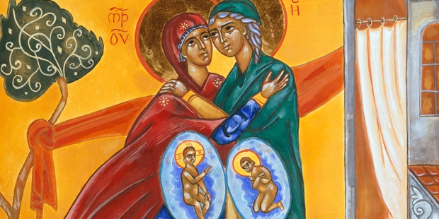
The certainty of God’s love is expressed in the joyful proclamation of the ‘Magnificat’. The gratitude she proclaims in this touching song is in harmony with the generosity of her daily ‘Fiat’. Mary praises God because He looked upon her simplicity, because He saw in her a docile and fruitful soil in which to work His salvation.
Everything by love, nothing by force
We contemplated the example of Mary who, allowing herself to be embraced by God’s grace and love, lived her life in joyful adherence to the divine will.
This conviction of Love that touches and transforms lives was well expressed in the words and testimony of St Francis de Sales. As we celebrate the 400th anniversary of his passage to heaven, let us draw on the wisdom of his message to enrich our reflection. With the same certainty that God continues and updates his covenant with humanity, Francis de Sales points to a starting point.
“In order to take the first step into God’s love, it is necessary that He, by manifesting Himself to man as God-Love, attracts him and solicits his freedom. But it must be made clear that God’s role goes even further. He is not content with inviting our heart to choose but also helps it in this choice… Man’s choice of love is an act of the human heart and the heart of God”. (Saint Francis De Sales)
To the extent that we are attracted by God’s love, the desire grows in us to discover what He asks of us and to assume an increasingly evangelical lifestyle. Each person, feeling personally loved, makes his or her free choice of love in the style proper to the vocation to which he or she has been called. Precisely because fidelity is patiently woven into everyday life and because it is not always easy to live in true harmony with God’s will, the response we give to God must be built on the foundation of faith and in a constant renewal of love.
Francis de Sales reminds us that the spirit of freedom, proper to those who love and have placed their trust in God, is the criterion that inspires our obedience and makes us truly docile for a mission: “We must do everything with love and nothing with force. It is better to love obedience than to fear disobedience. I leave you with the spirit of freedom, the spirit that excludes coercion, scruple and agitation”.
The experience of feeling personally loved by God and the constant attention to what He asks of us, introduce us to the dynamic of self-sacrifice and charity. It is from there that the task of human fulfilment begins, a reality in which an authentic spiritual journey has its fulfilment. Love “is the movement, journey and direction of the heart towards good” (F. De Sales). If God loves us, it is through the concrete practice of good, through the constant exercise of charity towards our neighbour that we can best express our love for him. We will be able to serve, educate and live our mission in the world if we open ourselves with docility to His will, inspired by the way God himself loves us.
Following Mary’s example and drawing from the sources of our Salesian spirituality, we are invited to re-read our lives and to confront ourselves with the response of love that we try to give to the Lord every day. Our daily ‘fiat’ is a free choice, the fruit of an experience of love that has overcome our will and becomes a visible sign for a world that seeks the light of the Lord.

For personal prayer and meditation
- Do I feel personally loved by GOD?
- Do I perform concrete acts of charity, following the example of Mary?
- Do I open myself with docility to God’s will, an expression of understanding how He loves me?
- Is my daily response to the Lord, the fruit of feeling deeply loved by Him?
Monthly commitment
I will try to give thanks every evening for a small or a big good thing that has happened that day.

6. THE PRIMACY OF GRACE: JOY, GIFT OF THE HOLY SPIRIT (THE THEOLOGICAL VIRTUES)

“We must learn to dwell in our weakness, but armed with deep faith, accept that we are exposed to our weakness and at the same time surrendered to God’s mercy. Only in our weakness are we vulnerable to God’s love and power” (A. Louf)
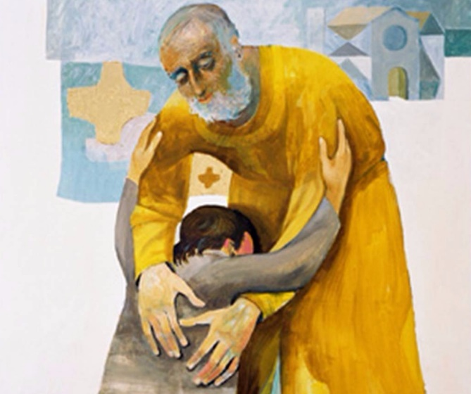
“So, if you have been raised with Christ, seek the things that are above, where Christ is, seated at the right hand of God. Set your minds on things that are above, not on things that are on earth, for, you have died, and your life is hidden with Christ in God. When Christ who is your life is revealed, then you also will be revealed with Him in glory. Put to death, therefore, whatever in you is earthly: fornication, impurity, passion, evil desire, and greed (which is idolatry). Do not lie to one another, seeing that you have stripped off the old self with its practices and have clothed yourselves with the new self, which is being renewed in knowledge according to the image of its creator. In that renewal there is no longer Greek and Jew, circumcised and uncircumcised, barbarian, Scythian, slave and free; but Christ is all and in all”. (Col. 3, 1-5.9-11).

“Rejoice in the Lord always; again I will say, Rejoice. Let your gentleness be known to everyone. The Lord is near. Do not worry about anything, but in everything by prayer and supplication with thanksgiving let your requests be made known to God. And the peace of God, which surpasses all understanding, will guard your hearts and your minds in Christ Jesus”. (Phil. 4:4-7).

- Living in Christ
“If therefore you have risen with Christ, seek the things above where Christ is seated at the right hand of God; think of the things above, not of those on earth”. This is how the Apostle introduces himself in his letter to the Colossians, reminding us of our radical vocation given to us through baptism, namely that of being “buried with Christ in order to rise with him (...) stripped of the old man and clothed with the new, which is being renewed, to a full knowledge in the image of its Creator.”
We are called to rediscover the power of baptism which is expressed in the primacy of Grace; Most Holy Trinity has taken possession of our existence and dwells in us. The apostle himself expresses this very well in I Cor. 6:19-20: “Do you not know that your body is the temple of the Holy Spirit who is in you, whom you have from God, and that you do not belong to yourselves? For you have been bought dearly; glorify therefore God in your body and in your spirit, which belong to God.”
Spiritual life is Christ living in us through the Holy Spirit. That Christ lives in us through His Spirit is not a pious sentiment, but the only way we can be joyful. It is then understood that it is not enough to live ‘for’ Christ, but we must move on to live ‘with’ Christ in order to arrive at living ‘in’ Christ. For this to be accomplished, it is essential to backtrack. Jesus states that it is necessary to lose one’s life for Him and for the gospel (Cf. Mk 8:34ff). But how? And backtrack from what? A passage from First Corinthians lifts the veil: “Because of him you are in Christ Jesus, who became for us wisdom through God’s work, righteousness, sanctification, and redemption, for as it is written, whoever boasts, let him boast in the Lord” (1 Cor. 1:30-31). Wisdom, righteousness, sanctification, redemption - One must reflect on these points. When I give up being for myself, my wisdom, my righteousness, my sanctification, my redemption, then Christ moves from being ‘with me’ to living ‘in me.
When man understands that Christ is all his wealth, he does not pretend to be good or disguise himself as a master of himself. Either I am in Christ or I am one of the many mortals invited - unwillingly - to the carnival of a passing world. If we choose to follow him but do not allow the Spirit to sanctify us, we remain in the middle of the ford, lost between a drab faith and a world watched from afar with nostalgia. Absurdly, it would be better for us not to have known Christ.
Joy lies in the warmth of his presence ‘in’ us, not in just for or with. Thus wrote Isaac of Nineveh: “This knowledge, my beloved: wherever there is joy from God, it comes from fervor, and, everywhere, the cause of joy is fervor; for where there is no fervor, there is no joy either.”
- A life of faith, hope and charity
The spiritual man, that is, one who lived in the primacy of grace, who lets Christ dwell in him, has a pure heart and because of this, sees God, becomes a sharer in his wisdom and able to interpret the most difficult situations with supernatural insight, pointing the right way. We can think, for example, of Blessed Eusebia Palomino, a very simple nun who worked in the kitchen, to whom priests, seminarians and young girls went to seek advice for their journey of faith. The depth of her union with God was the secret of a wisdom that is learned only by drawing it from the source of loving intimacy with the Lord.
Therefore, when St. Paul states, “we have the thought of Christ” (1 Cor. 2:6), he makes a very strong statement.
Faith and spiritual experience become the principle of a new knowledge which broadens the horizons of reason and opens them to participate in the month of the Risen Crucified. Having the thought of Christ does not mean just having new ‘ideas’, but a way of thinking that is connected with a way of acting, of feeling, of being. To realise this, we need only to think of the very harsh words Jesus addressed to Peter in Mk. 8:33: “Get behind me, Satan! For you do not think according to God, but according to men”. Peter, even after having confessed his messianic faith in Christ, shows that he still does not think according to Christ. Rather he reasons according to a logic that is an obstacle to the way of Jesus.
The virtue of Faith leads us to have, instead, the ‘thought of Christ’ and then I know (and experience) that God loves us and that Christ died for us, out of love.
Pope Francis offers us an extraordinary focus on this issue in his first encyclical, ‘Lumen Fidei’, an early draft which bears the signature of Benedict XVI. In particular, at number 18 of this text, we can read the following enlightening expressions.
“In faith, Christ is not only the One in whom we believe, the ultimate manifestation of God’s love, but also the One to whom we unite ourselves in order to believe. Faith not only looks at Jesus, but looks from Jesus’ point of view, with His eyes: it is a participation in His way of seeing. In so many areas of life, we rely on other people who know better than we do. We trust the architect who builds our house, the pharmacist who offers us the medicine for healing, the lawyer who defends us in court. We also need someone who is trustworthy and is an expert in the things of God. Jesus, His Son, presents Himself as the One who explains God to us (cf. Jn 1:18). The life of Christ - His way of knowing the Father, of living totally in relationship with Him - opens up a new space for human experience and we can enter it.”
Hope, consequently, is believing that at the bottom of everything that exists is hidden something good. Hope itself, indissolubly linked to faith, as the letter to the Hebrews states: “Now faith is the assurance of things hoped for, the conviction of things not seen” (Heb 11:1). Christian hope is summed up well in this statement: “In the end, the beginning”. Hope is grounded precisely in Christ’s end, in His death that was His true beginning, in the resurrection. It lifts us out of what we have always experienced as ‘the end’. The God of hope always creates a new beginning in life, while in death He awakens us to new life in the world to come. Hope is ‘faith cast forward’. A great French man of letters and convert, Charles Peguy, in his book ‘The Porch of the Mystery of the Second Virtue’, imagines hope as a little girl giving her hand to her two big sisters, faith and charity, and

“the little hope. It advances. And in the midst of her big sisters, she has the air of letting herself be pulled like a little girl who does not have the strength to walk. And that she pulls herself along that road in spite of herself. And in reality, it is she who makes the others walk and who pulls them, and who makes everyone walk and who pulls them. Because one never works but for the children. And the two big ones only walk for the little one (...) Hope does not go by itself. To hope, one must be very happy, one must have obtained, received a great grace.”

Once again, we see how the intimate bond between the theological virtues is joy! For this hope to be possible, one must be very happy and have the experience of feeling loved. The life of grace is at bottom simply this: letting oneself be loved and loved.
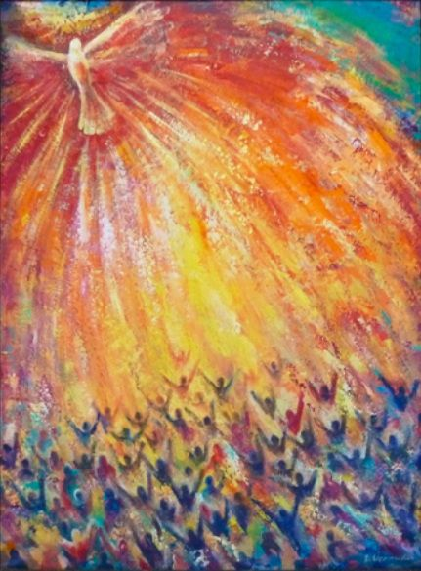
In love, in agape, all the virtues are summed up, as St. Paul’s hymn to charity beautifully states: “And now faith, hope, and love abide, these three; and the greatest of these is love” (1 Cor 13:13). Do you know why? Because the only thing that God the Father and the Son desire for us is to bring us His love, that is, the Holy Spirit, His grace! Otherwise, everything is empty, everything is sterile, everything is grey; it brings us no fullness, no happiness.
When we need to renew ourselves personally and communally, the starting point must always be this: our families, our communities, our relationships, our own life is either founded on love or it is not. The starting point is to let God do this, which is why He created us, why He redeemed us through His Son, why He remains with us, in the Church with His Spirit.
Hidden in his love are three things we all desire: belonging, meaning and destination.
Belonging: only love makes us answer the fundamental question that runs through our lives: who am I for? One can only enjoy life when one feels one belongs to someone.
Meaning: only love fills our lives with meaning. Most of the spiritual and psychological pathologies experienced by many people, especially young people, are due to the fact that we do not feel loved.
Destiny: this is the third characteristic. Love gives us a destiny. What is the destination for each of us? To come home, to Him. To know that you are loved is to know that you have a home where you are going. To have a reason to wake up. To feel that everything you do has a direction.
Love attracts us. This is the primacy of grace. It also requires the commitment of our freedom which chooses to grow in those virtues without which love would not find the possibility of realisation and would remain at the level of sentiment or, worse, emotion.

- Joy as its fruit
The fruit of a life lived in faith, hope and charity is joy, which thus becomes the hallmark of a Christian. Pope Francis expresses this well at the beginning of his programmatic text ‘Evangelii Gaudium’.
“The joy of the Gospel fills the heart and the whole life of those who encounter Jesus. Those who allow themselves to be saved by Him are liberated from sin, from sadness, from inner emptiness, from isolation. With Jesus Christ, joy is always born and reborn (...)
The great danger of today’s world, with its manifold and oppressive offer of consumption, is an individualistic sadness that springs from a comfortable and stingy heart, from the sick pursuit of superficial pleasures, from an isolated conscience. When the inner life closes in on one’s own interests, there is no longer any room for others: The poor no longer enter, God’s voice is no longer heard, the sweet joy of his love is no longer enjoyed, the enthusiasm to do good no longer palpitates. Believers also run this risk, certain and permanent. Many fall into it and turn into resentful, discontented, lifeless people. This is not the choice of a worthy and full life; this is not God’s desire for us, this is not life in the Spirit flowing from the heart of the risen Christ.
I invite every Christian, in whatever place and situation they find themselves, to renew their personal encounter with Jesus Christ today, or, at the very least, to make the decision to allow themselves to be encountered by Him, to seek Him daily without ceasing. There is no reason for anyone to think that this invitation is not for him/her, because «no one is excluded from the joy brought by the Lord» (n.1-3)”
The link between a life informed by the theological virtues and joy is beautifully expressed in the Divine Comedy when Dante is near the summit of Paradise (Canto XXIV). At the end of his extraordinary journey, he is questioned by three apostles about the three theological virtues. On faith he is examined by St. Peter, who, after asking him what faith is and whether he is endowed with it, asks Dante where he received it from. The prince of the apostles formulates the question in this way: “This dear joy, upon which all virtue is founded, whence did it come to you?”. It is clear that the ‘dear joy’ spoken of here is the precious pearl – joy, of which the Gospel speaks. It is the gem to obtain for which it is worth sacrificing everything else.
Another passage from the Comedy cannot fail to come to mind. Right at the beginning of the journey, in the first canto of the Inferno, Dante is lost in the dark forest, sees a person and asks him for help. It is Virgil, who asks him why he does not decide to climb ‘the delightful mountain which is the beginning and cause of all joy’. He cannot because there are three beasts that impede his passage and therefore the Florentine poet will have to be accompanied on ‘another journey’. The one, precisely, that will take him before reaching St Peter. A journey whose destination is joy or, better, the happiness that only those who have found the pearl - joy of faith - can enter.
Faith is truly the ‘dear joy’, a happiness that is dear to us, ‘above which every other virtue is founded’. For, if faith were not true, we could not fully have hope since the world would be doomed to death, and neither could we have full love, capable of the total forgiveness that only Christ bestowed from His Cross. Every other virtue is founded on the joy of faith, every desire to grow in our humanity, and every walk of life. But today more than ever it is fundamental, as Christians living the spirit of Don Bosco, that the most beautiful fruit of our life of grace is the joy of giving joy! This is the road to Christian happiness. Today it is more necessary to give evidence with our lives to this truth: only those who are committed to making others happy can be happy. Only he who strives to create the conditions for others to live in joy, can taste joy. Only those who strive to make contentment circulate in the lives of others can have an authentic experience of contentment.
We can end our reflection with a note of realism offered by St. Francis de Sales: “Go forth with joy and an open heart as much as you can; and if you do not always go with joy, always go with courage and confidence”.

Questions for personal reflection
- To live by faith, hope and charity: What does it mean concretely in your life?
- What has helped you most in your life to grow in these virtues, which are first of all a gift from heaven, but which require the contribution of your freedom?
- What, in this period of your life, is holding you back from faith, hope and charity?
- Do you experience deep joy or do you live on the wave of your emotions?

Monthly commitment
Every evening, in prayer, let us give thanks for a beautiful thing received, by training ourselves to smile even in moments of difficulties.

7. GRACE SUPPOSES NATURE: THE EXERCISE OF THE VIRTUES

Along with the struggle against the most common temptations, we are called to foster the action of the Holy Spirit through the virtues. They will help us in particular, Humility and Meekness, character traits of Jesus, “Learn from me who am meek and humble of heart”. (Mt 11:25-30)

As St. Francis de Sales says, “Bear with gentleness the little injustices, the small inconveniences, the losses of little importance that happen every day. These small occasions lived with love will earn you God’s heart and make it all your own”.
We will better understand how the development of virtues can help us grow in peace and love: patience, meekness, humility, poverty of spirit (even in the midst of riches), avoiding backbiting and judgments. We will seek not only to love others but to make others feel loved, drawing on the great wealth of Salesian spirituality and Don Bosco: loving-kindness, tireless work and Salesian temperance and optimism.
Let us remember Pope Francis’ three words: please, sorry and thank you.

1. What is humility?
The Greek term for humility used in the Magnificat (“he looked upon the humility of his servant”, Luke 1:48) and in St. Paul’s Christological hymn to the Philippians (“he humbled himself by becoming obedient unto death”, Phil 2:8) is the noun tapeinòs and the verb tapeinòo.
When reading Mickey Mouse as a child, there were episodes in the stories of Uncle Scrooge concerning the loss of his vast fortune; whenever such situations occurred, Uncle Scrooge’s comment was, ‘me tapino’(me poor man!!). Where does it come from and what is the meaning of the expression? In the study of the Greek language, the term tapeinòs has five meanings depending on the context: 1. of places, low, depressed; of stature, short; 2. of lowly person, humbled, submissive and still lowly, humble, mean, small, poor, weak; 3. spiritually depressed, dejected; 4. morally mean, vile, modest, humble; 5. of things, modest, resigned, poor.
The semantic reference for both contexts of the Magnificat and the hymn to the Philippians is that of the person. In the case of Mary, humble, lowly handmaid, poor and weak; in the case of Jesus, humble and submissive. The two contexts both help us to understand in depth the meaning of being humble; one is helpful in explaining the other. To be humble like Mary and thus find God’s complacency, there is a need to be humble and submissive, as Jesus was at the moment of His death on the cross, His most extreme lowering. In short, there can be no humility without humiliation.
These two realities seem directly proportional. If one is weak and poor in reality or feels so, it is really the moment when one can be lifted up: “He who is lifted up will be humbled (tapeinòo) and he who humbles himself (tapeinòo) will be lifted up” (Lk. 14:11). It is really the praise of frailty, a situation in which God can enter, pitch his tent, build his dwelling place and inhabit it.
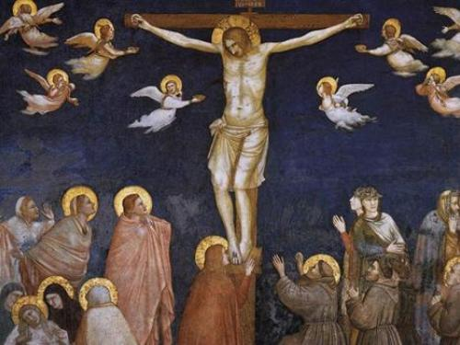
2. What is the significance of the passage of “learn from me that I am meek and humble of heart” (Mt. 11:25-30)?
The passage is placed at the end of chapter 11 and is preceded by John the Baptist sending two disciples to Jesus to ask Him if He was indeed the Messiah. John, who was Jesus’ cousin, chosen to be His messenger, had recognized Him since He was in the womb of His mother Elizabeth exulting with joy at Jesus’ visitation in Mary’s womb, now wonders if He is “the One who is to come, or must we wait for another?”.
Jesus answers with the characteristics of the Messiah mentioned by the prophet Isaiah: “the blind recover their sight, the crippled walk, the poor are told the good news...” To this question Jesus adds praise toward His cousin and a confirmation of his mission as a forerunner. The contrast is really sharp between the Baptist’s demanding proclamation to conversion and the lack of reception of his message and what Jesus himself is proclaiming. Truly the cities by the Lake of Galilee in which many miracles took place did not believe in the power of Christ.
Immediately the passage is followed by the dispute with the Pharisees about the Sabbath and the temple. Jesus, Lord of the Sabbath, reiterates, “Mercy I want and not sacrifice.”
Between these two passages lies the present text. Recognizing Jesus as the Messiah, accessing His filial relationship with the Father, knowing Him in depth to the point of experiencing Him: it is not the result of human effort; it is not tied to knowledge and observance of the law; it is not achieved through demanding asceticism; it goes beyond the hardness of heart of not accepting His miracles. It is a free gift from the Father (it pleased Him). So much so that Jesus thanks Him with a public confession in the form of a prayer for all to hear: “Bless you, Father, Lord of heaven and earth, for you have hidden these things from the wise and the intelligent and revealed them to the little ones.” Only the little ones, the poor, the humble can access the knowledge of God.
Those who are big, rich and proud, full of themselves, relying only on their own strength, self-sufficient, can never know the breadth, width and depth of God’s love. And here is Jesus’ punch line, “Everything has been given to me by my Father, and no one knows the Son except the Father, and the one to whom the Son wishes to reveal him.” The Father-Son relationship is one and it is totalizing: everything is given by the Father and the Son. And Jesus’ knowledge of the Father is unique: He, the only begotten of the Father, begotten not created, of the same substance, in the bosom of the Father from eternity and forever is the One who becomes incarnate, becomes man, lowers Himself to death on a cross, reveals the face of the Father because He is one with Him. One cannot access the Father except by passing through the divine person of the incarnate Word.
And here is the invitation to everyone in their existential frailty: “Come to me all you who are weary and tired and I will give you rest.”
Fatigue and weariness are two life situations often present in human beings; they affect not only the physical dimension, but much more the moral, existential and spiritual dimension.
We cannot but think of the anguish of pandemic times, the absurdity of wars, the economic uncertainty, the difficulty of growing up, of taking on new responsibilities, of illness and old age. In these two fatigued and weary terms are the men and women of all categories and at all times. In the face of harsh reality, of adverse history, there is the bursting proclamation of relief from Jesus. We ask ourselves: Who will come to our rescue? Who will deliver us? Jesus answers tenderly: “I will give you freshness. I will quench your thirst. I will give you that living water that quenches your thirst for eternal life. I will wash your feet and serve you. Do you not notice? Right now a new thing is budding.”
Take my yoke upon you. Jesus gives us a burden. It is His burden. He becomes a burden for us. The yoke is a wooden plank for leading animals in pair and aiding the driving of the chariot. The yoke is always for two: one is Jesus and the other is us. You are never alone. It’s awesome, the image of being in pair with Jesus -- where the burdens are shared. That’s why it says at the end that His yoke is gentle (becasue He paired with me) and His burden light (because He bears the heaviest part. He is the one who carries the cross for me). We are called to be Cyrenees with Him, Cyrenees of His cross but also of His joy.
Verse 29 highlights a teaching statement, “Learn from me, for I am meek and humble (tapeinòs) in heart, and you will find rest for your souls.” We recognize the master and Lord if we put ourselves in his school of meekness and humility, if we are meek and meek like the Immolated Lamb, condemned, humiliated, abused, vilified like the Crucified One. The price of humility is humiliation, and the fruit, salvation and joy.

3. What does St. Francis de Sales say about humility and meekness?
True humility is generous. For, the more the humility brings us down to the knowledge of the nothingness that we are to ourselves, the more it makes us esteem the virtues that God has showered on us, especially faith, hope, love and that certain capacity that He has given us to unite ourselves with Him through grace. This appreciation that humility makes of God’s gifts is the foundation of generosity of spirit. Humility convinces us that we can do nothing by ourselves since it makes us recognize our wretchedness and limitation. Generosity, in turn, makes us say with St. Paul, “All things I can do in Him who gives me strength.” Humility makes us mistrust ourselves; generosity makes us trust in God. These two virtues are so united to each other that there cannot be one without the other nor can they ever be separated. Humility is grateful; That humility prevents us from seeing the good that God has put in us, is not true. In fact, God’s gifts must be recognized and esteemed.
To know oneself means to recognize not only one’s own nothingness but also the great dignity that God has placed in us by creating us in His image and likeness, capable of uniting us with Him and endowed with a certain instinct that makes us strive and aspire for this union. True humility is full of love and in the service of love, so much so that it can be said that charity is a rising humility and humility is a descending charity. Humility hides and covers virtues in order to preserve them; it lets them be seen when love demands it. Thus, it does not parade its gifts, but when charity demands, it knows how to give its neighbor with frankness and gentleness not only what is useful to the person but also what pleases him. So, all forms of humility that bring prejudice to charity are certainly false. Again, true humility is gentle, strong, serene and gracious. By walking with simplicity on this path, we will make ourselves pleasing to God because He is pleased with humble hearts.
Therefore, I urge you to be joyfully humble before God as well as before the world. Do not seek visible humility. Without avoiding it when the opportunity arises, embrace it joyfully. Take care, however, that your outward humility is always a true expression of your heart.
Guard your littleness with love because God looks upon it with complacency and fills it with grace. Love your poverty, rejoice in being empty that the Lord may fill you with His Kingdom. So, nourish your soul with a spirit of humble and hearty confidence in God. As you find yourself frail and miserable, learn to hope more boldly in Him. You will thus practice great humility, generous and quiet. In the service of God, it will preserve you in a filial and loving freedom without embittering your heart and will keep in you a spirit of holy joy. (Cf. Spiritual Retreats, V, 2-4; VIII, 14; III, 20. Introduction to the Devout Life (Philothea) III, 5. Letters of 1-11-1604; 1607; 8-1608).

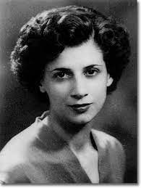
4. What can a poor little Salesian Cooperator (Vera of Jesus) teach us?
Vera: O my Jesus, I have nothing to give You. I find nothing but your own gifts and I offer them to You. I intend to offer them through the Heart of your and my sweet Mother together with my poor will. O Jesus, do Thou, destroy me but may I not resist Thee, make me humble, take my whole heart: may it beat only for Thee and may I tell Thee in every beat that I love Thee, that I detest sin. My Life, let me have no other Life but Thine, no other sigh but Thine, no other breath but Thine.
Jesus: “In the holy name of obedience, listen to my Voice: it is Cross, it is Love. My Love and My Cross will never leave you, so will be MY VOICE. Accept it out of obedience, out of love and in a spirit of humility and penance. Behold, I AM in you in love and sorrow. This Voice, my voice, will be the fire that will purify you. I want MY TEMPLE to burn, to be consumed for me. Thank me, my child, that My Father’s love is great for you. Tomorrow, at Holy Mass, you will bring my gifts, the gifts of my mother’s heart, and you will unite them with your miseries, your nothingness, your very small heart. I will take everything. Remember: the wine and the water. In this mystery is the union, the giving. Only with me does the offering rise to God the Father. O my child, immerse yourself in my love. Only my grace will sustain you. Look at me in the Cross, love me in the Cross, fasten in the Cross: I draw you to me, Jesus. Do everything in my name and for my love. When weariness crushes you, invoke me: I will help you!” (Take me with you, 117).
Jesus: “Gift of God, Gift of Love. My Love has no boundaries, no barriers. It is not your miseries that prevent my Grace in you because my Grace is LOVE. It is your doubts, your uncertainties, the limits you place on abandonment in me: Jesus! How fragile you are, My child! Come to Me: I am the STRENGTH, your strength. Think of the Tabernacle. You believe in MY PRESENCE in the Tabernacle. Believe in ME, your Jesus does not deceive you. It is I, Jesus! I would speak to any sinner if he had faith in Me, if he believed in Me, in My Love. I would show Myself to him as I once did, even in My Holy Humanity, but he still would not believe because he has no Faith. If Faith has grown in you, know that it is My Gift! Believe Me speaking to you and ask no more, do not explain why: so, it pleased MY FATHER, so it pleases Me. You receive in humility and gratitude My Voice. Return to Me, surrender yourself to My Love. Feel My Cross, feel My Yoke! Let Me penetrate you.” (Take Me with you, 120).
Vera: O Jesus, give me the pain of sins, a pure and holy LOVE, give me the gift of humility and obedience. O Jesus give me ‘everything’ because I have nothing. Thank you. (Take me with you, 122).
Jesus: “Now, My child, listen to Me: it is My Father’s will that you be recollected, humble, waiting for Me. I call you to fulfill a mission. Fear not, you have the Love Force. I will lead you through rough and winding paths, but in the end, you will recognize Me because I will be there waiting for you. Yes, it is Jesus of the Tabernacle who speaks, who calls, “I am.” You have to do nothing, for now, but wait for Me. I prepare ‘My ways’ by which you and many other souls will set out.
I want you for ME ALONE, I remove you from the worldly affections. I put ‘everything and everyone’ in the Hands of my Father, your family members and I will think of them, but you think only and always of Me. You will have to ‘depart’ from this world, leave it for Me, detach yourself for Me. A Bride is not of the bridegroom if she is not crucified with the relationship. I draw you to the madness of the Cross.
See, I make you a ‘gift’ of My riches, of My passions: passion of Love, of Sorrow; sacrifice, offering, immolation of My Blood.
My poor daughter, you see nothing of all this yet! I, Jesus, Way, Truth, Life will announce many things to you in due time. Remain in humility, in my Love, in my Grace. With the forgiveness of your sins, I redeemed you, in the washing of My Blood, I purified you yesterday, today and will purify always.
You need every day this baptism of Blood and only in My Blood does this happen. Prepare yourself, My daughter, soon I will come to you. It pleased My Father. So, it still pleases Him to make use of the poorest and most unpleasant creatures, but redeemed by My Blood, for His will. You are ‘nothing’ and for this you fear. I have told you that I speak to you in the Heart of my Mother, and through that sword that pierces your Mother’s Heart, my Voice comes to You. From ‘Her’ hear me. Now pray, pray to My Father that He may be pleased to answer your prayers.
When they arrive at My Father’s Throne, they must have the fragrance of incense. Ask Me for incense in your prayers and then unite them with those of the Church, of the Pope; bring them to Father Gabriel so that he may offer them to Me. Ask for My Kingdom, My Will, My Love, My Grace, My Blessing on all humankind. Toward evening, I descend into the world, among souls and I look at them, I search them... Yes, I descend with My Grace into the souls who have served Me. I infuse peace and serenity into their hearts: They are ‘My treasure’ on earth. Fr. Gabriel will speak to souls by My mouth, and My Voice will pass into hearts. For this, your heart must suffer. It must bleed. Send it to Father Gabriel that he may offer it to Me in the Heart of My Mother of Sorrows. Write this so that he may know My Desires. To other souls, I will tell My Love; I will use them to embrace all.
Conclude with this particular Blessing of Mine: I want you all; I want you safe; I want you in My Kingdom. Yes, My child, I am your beloved Jesus yes, yes, yes, it is I, Jesus.” (Take Me with You, 128).

For personal prayer and meditation
- Can I endure small injustices or daily setbacks with patience and gentleness?
- In difficulties, do I break down and get angry with myself, letting pride overcome me, or do I surrender myself to God and tell myself, “All things I can do in him who gives me strength?”
- When I am fatigued and tired, do I ask Jesus for help in prayer, certain that I can partner with Him and that He will bear my burdens?
Monthly commitment
I commit myself not to complain in the face of difficulties and setbacks and say “Jesus, I trust in you” and “I can do all things in Him who gives me strength.”

