DECEMBER EDITORIAL

HOLY MARY, MOTHER OF GOD
Dear friends of ADMA,
Cordial greetings and best wishes to each of you, to your families and friends, to all the children of Mary. We are in the liturgical season of Advent and Christmas. Although the Child Jesus is at the centre of the mystery of the Incarnation, this season is full of Marian references. It can be said that without Mary there would be no Christmas, because it was God the Father who chose a woman to get in touch and in relationship with all of us, assuming our human condition in all things but sin. Without Mary we could not celebrate the feast of the Holy Family, which we honour every year on the last Sunday of December. This is a reality that Pope Francis wants to be guarded, cared for and contemplated with faith and dedication. Undoubtedly the most important Marian feast of these days is the solemnity of Mary, Mother of God, with which we begin every year.
This was the first Marian feast to appear in the Western Church. The antiquity of this Marian celebration is reflected in the paintings with the name "Mary, Mother of God" (Theotókos) which were found in the catacombs beneath the city of Rome.
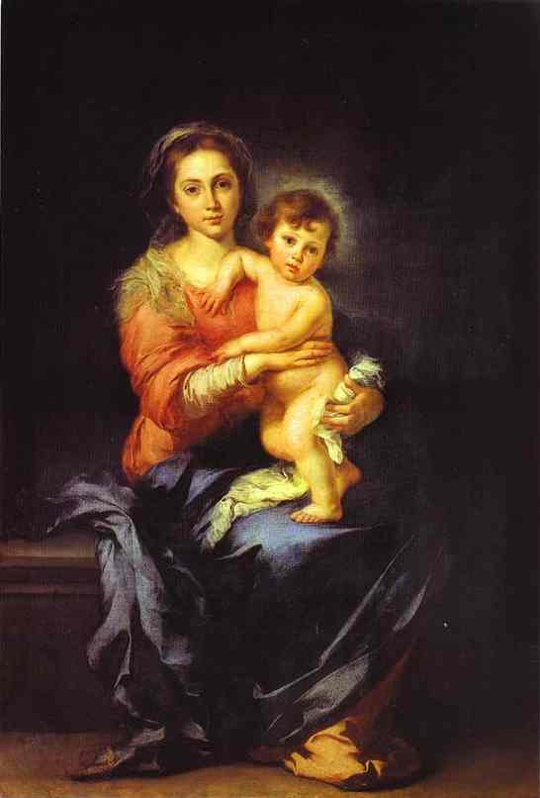
Later in the Roman rite the feast was celebrated on the first day of January on the octave day of Christmas, commemorating the circumcision of the Child Jesus. In later years the feast disappeared from the liturgy, but in 1931, Pope Pius XI, on the occasion of the 15th centenary of the Council of Ephesus (431), instituted the Marian feast again, to be celebrated on 11 October, in memory of the Council in which Mary Most Holy was solemnly proclaimed as the true Mother of Christ, who is the true Son of God. Finally, with the reform of the calendar - after the Second Vatican Council - the feast was moved to 1 January, with the highest liturgical rank of solemnity and with the title of Holy Mary, Mother of God.
In this way all Catholics begin the year by invoking the protection of the Blessed Virgin Mary. What better way to start the year than by admiring Mary, as the shepherds did when they came into the presence of the Holy Family! We are filled with admiration, because life is a gift that always offers us the possibility of starting over again.

We admire the Mother of God: God is a child in the arms of a woman who feeds her Creator. This image shows us the Mother and the Child so united that they seem to be one. It is the mystery of communion, which we are invited to experience in this new year. God and humanity always together; all human beings and Mary always together ... This is the good news of the beginning of the year: God is not a distant Lord who lives only in heaven, but Love incarnate, born like us of a mother to be a brother of each one, in order to be close to us - he is the God of closeness. And this miracle is possible thanks to a woman, thanks to a mother, thanks to Mary. Jesus is in the womb of his mother who is also our mother, and from there he pours out a new tenderness on all humanity.
At the beginning of the year, we ask Mary for the grace to marvel at the God of life and love. We welcome the mystery of the Mother of God with awe and reverence like the people of Ephesus at the time of the Council. Like them, we acclaim her "Holy Mother of God". Let us allow ourselves to be looked upon by her, let us allow ourselves to be embraced, let us allow her to take us by the hand.
Renato Valera, President ADMA Valdocco.
Alejandro Guevara, Spiritual Animator ADMA Valdocco.

AUGURI DI SANTO NATALE DA PARTE DEL CONSEJO DE ADMA IN ITALIANO.
https://www.youtube.com/watch?v=g7Iy96rRtBE

FELIZ NAVIDAD DEL CONSEJO DE ADMA EN ESPAÑOL
https://www.youtube.com/watch?v=zRVRill5p2w&t=36s

MERRY CHRISTMAS FROM ADMA'S COUNCIL IN ENGLISH
https://www.youtube.com/watch?v=kUoEzFCfkDk

FORMATION PROGRAMME 2021-2022
Family love, vocation and life of holiness

DAILY LOVE

1.- SALESIAN LOVE AND THE HYMN OF CHARITY
Don Bosco's Preventive System (Reason, Loving Kindness, and Religion) represents the essence of Don Bosco's pedagogical wisdom and constitutes the prophetic message that he left to us and to the whole Church. (P. Chávez, Aguinaldo 2013).

Don Bosco's loving kindness, understood as close and caring kindness, is one of the traits that is considered most valid today, both in Christian contexts and in other contexts where young people of other religions live. It is not only a pedagogical principle. It is an essential element of our spirituality. (P. Chávez, Aguinaldo 2017)
This "loving kindness", which can also be translated as affection or personalized love, is not just part of a family or educational strategy: either you act from the heart, or you pretend to love someone.
It is worth saying that the charism of the Preventive System - "you will make them friends not with blows, but with affection" (dream at nine - puts us in the Salesian Family in a privileged situation to understand more readily the reflections of Pope Francis.
We pay close attention to the text of the Encyclical. "Amoris laetitia", art. 90, which begins with St Paul’s hymn of Charity from the letter to the Corinthians. These reflections are made with eyes wide open. They are relevant and realistic today and deserve to be read calmly with an open heart.
Love is patient; love is kind; love is not envious or boastful or arrogant or rude. It does not insist on its own way; it is not irritable or resentful; it does not rejoice in wrongdoing. But rejoices in the truth. It bears all things, believes all things, hopes all things, endures all things. Love never ends.

As we read and reflect on this marvelous description of charity according to the heart of Christ, the Good Shepherd, the echoes of Don Bosco's messages resound in every Salesian heart: “One who knows he is loved loves in return, and one who loves can obtain anything, especially from the young.” “Why do you want to replace love with cold rules? ... This is sure to happen if there is no friendly relationship.” (Letter of Rome) “Education is a matter of the heart.” (Don Bosco's letter on punishments) This is the greatness and the secret of Don Bosco's success as educator and founder.

2.- WHAT IS THE SIGNIFICANCE OF THE HYMN OF CHARITY? HOW TO APPLY IT TO EVERY FAMILY?
The Pope begins by commenting on the word "patience".
Being patient is not about letting others abuse us all the time or allowing them to treat us as objects. We have a problem when we expect our relationships to be profound or expect people to be perfect, or when we place ourselves at the centre and expect only our own will to be satisfied. Love is not just a feeling. It must be understood as "doing good". "Love must be exercised more in deeds than in words" (St. Ignatius)

How to heal envy
By looking at the other with the gaze of God the Father, who gives us everything "for our enjoyment" (1 Tm 6:17). If we are envious and arrogant, we lose the sense of reality, we consider ourselves greater than we are, more "spiritual" or "wiser". But sometimes the opposite happens: those who consider themselves "important" within their family become arrogant and unbearable. To understand, excuse, or serve others from the heart, it is essential to heal pride and cultivate humility. ... "Whoever wants to be first among you, let him be your servant." (Mt 20:27).

Be kind!
What Pope Francis recommends is in total harmony with the message of the Preventive System: Being kind is the hallmark of the Christian. Those who love know how to speak words of encouragement, comfort, support, stimulus. Jesus said to the people: "Take heart!" (Mt 9: 2). "You have great faith!" (Mt 15:28). "I tell you to get up!" (Mk 5:41). "Go in peace" (Lk 7.50). "Do not be afraid" (Mt 14,27). We learn the language of Jesus in the family.

We must know how to forgive.
St. Thomas Aquinas explained that "charity is more about wanting to love than wanting to be loved." For this reason, love goes beyond justice and overflows freely, "without expecting anything in return" (Lk 6:35), until it reaches the greatest love, which is "giving one's life" for others (Jn 15, 13). When we are irritated, we are on the defensive towards others, as if they were annoying enemies. The description of Don Bosco given by a young student fits in well here: Don Bosco's kindness, his serene face, his customary smile, predisposed hearts and inspired respect and trust. Young people went to Don Bosco because they were at ease with him and they knew he was there just for them, as if there was no one else in the world.

Therefore, you should never end the day without making peace in the family. How do I make peace? Do I have to go on my knees? No! Just a small gesture, something small, and family harmony returns. A caress is enough, without words.

And know how to forgive. Leave no room for resentment, ignore mistakes, and don’t resort to "Because I said so!" The problem is that sometimes everything is given the same importance. So being able to blame others becomes a false escape. We must also forgive ourselves, and forgive others ... But this supposes the experience of first being forgiven by God ...

The family should be the place where we celebrate the joys of life
Love rejoices in the truth, that is, it rejoices in the good of the other. This is impossible for those who need always to be in comparison or competition, even with their spouse, to the point of secretly rejoicing in the failures of others. The family should always be the place where someone, who achieves something good in life, knows that they can celebrate it there with their loved ones.
"Bear all things": we must learn to overlook the faults that may exist in another person. We are all a complex mixture of light and shadow. The other is not just someone that annoys me. He or she is much more than that. Therefore, I do not expect the other person’s love to be perfect before I accept it. The other person loves me as they are and as they can within their limits. Love coexists with imperfection, excuses, and knows how to remain silent in the face of the limits of the loved one.

"Wait and endure everything": love trusts, does not try to control everything, to dominate. A family where everyone always trusts again and again, despite everything, makes it possible to reject deception and falsehood spontaneously.

Hope includes the certainty of a life beyond death. Each person, with all his or her weaknesses, is called to the fullness of heaven. This allows us to contemplate that person with a supernatural gaze, in the light of hope ...

This reminds us of the words of Martin Luther King: “The person who hates you most has some good in him; even the nation that hates you most has some good in it; even the race that hates you most has some good in it. And when you come to the point that you look in the face of every man and see deep down within him what religion calls “the image of God,” you begin to love him in spite of it. The strong person is the person who can cut off the chain of hate, the chain of evil.”

For personal reflection and group discussion
1. Which of the Pope’s reflections attracted your attention most for its originality? 2. What challenged you in a special way because it influenced your attitudes? What are you going to do about it? 3. Do you think it is an exaggeration to say that the Christian ideal of love is clearly anti-cultural? 4. How can we be witnesses of this love in a society profoundly marked by selfishness?

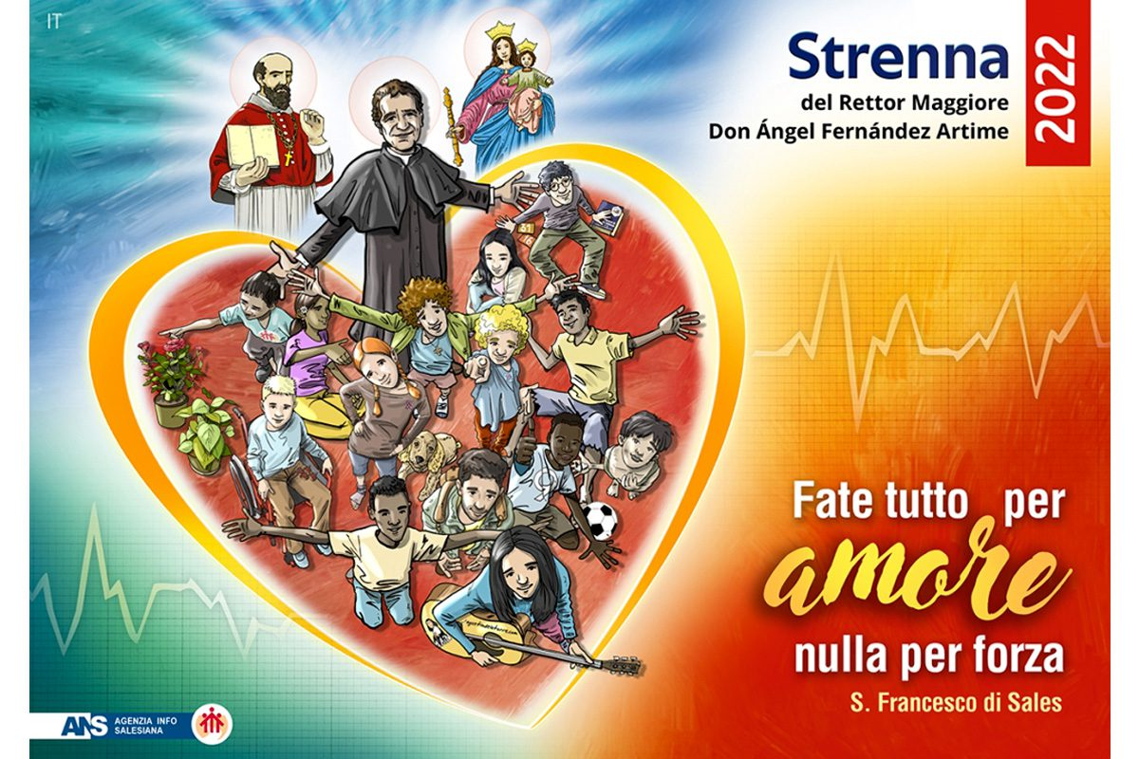
Do all through love, nothing by constraint

GETTING TO KNOW EACH OTHER– ADMA SAO PAOLO (Brazil)
Even in these difficult times the Association of Mary Help of Christians is alive and active. These are days of grace with many opportunities for conversion. As members of ADMA, we become witnesses of love for the Blessed Virgin, and we commit ourselves to making her known and loved. Our Lady has invited us to be part of the special Association which bears her name. We respond generously and enthusiastically, and we want to persevere.
We promise to imitate Mary’s spiritual attitude and to make our life an act of adoration of God. Like Mary, the Virgin who listens, we listen to the Word of God and proclaim it in our lives by participation in the liturgical life, in the Eucharist and in the sacrament of Reconciliation.
As a specific purpose characteristic of ADMA, we have been faithful to the participation of ADMA groups in the Mass on the 24th of each month, the monthly online formation in the various digital platforms that we have learned to manage, the adoration of Jesus in the Blessed Sacrament every Thursday, the visit of the Chaplain to the houses of the members, the recitation of the Holy Rosary in the town square and the thousand Hail Marys for priestly and religious vocations, and to collaboration in the life of the parish community and in social service.
It has been a time of great challenges, but we tried to make prayer a source of life and hope, imitating Mary in the spirituality of daily life. We tried to cultivate in our families and in the places where we live a Christian climate of welcome and solidarity with the sick and especially with those who have had the sad experience of COVID in their families.
We are trying to increase our attention to the young people of ADMA-youth, and the children of ADMA-children at this difficult moment of material and emotional deprivation. We are united with them always in their journey and in their difficulties. Here in the province of San Paolo we have 22 groups, including ADMA Adults, ADMA Youth and ADMA Children.
- Claudio Motta, Provincial Delegate of ADMA SP, for the period 2022-2025.

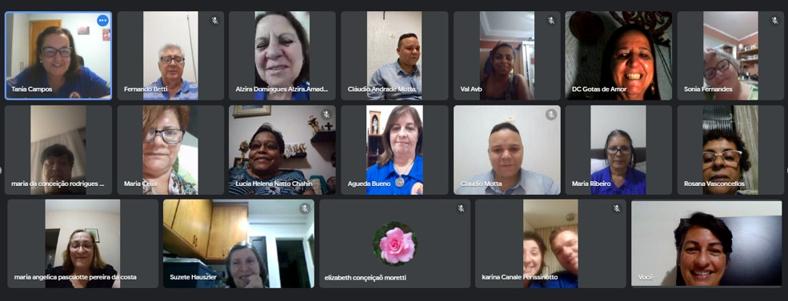

REGULATIONS

REGULATIONS OF THE ASSOCIATION OF MARY HELP OF CHRISTIANS

FOR STUDY AND IMPLEMENTATION

TO HELP US TO REALIZE OUR IDENTITY

ARTICLE 5 – SHARING IN SPIRITUAL BENEFITS (PART TWO)

As we saw in the previous article, the members share in the indulgences and in their own spiritual goods and those of the Salesian Family. To this end, "it is necessary and sufficient to be validly accepted and not legitimately dismissed from the Association" (can. 306). Placed under the mantle of our common Mother, Mary Help of Christians, they are a living part of the Mystical Body of Christ, in a communion of grace and spiritual solidarity that allows them to experience the strength of the Communion of Saints.
“The members also benefit from the fruits of worship and prayers that are offered in the Basilica of Mary Help of Christians in Turin and in the churches where the Association is erected". Each one’s journey of faith and grace benefits everyone and, through the intercession of the Help of Christians, the power of mutual prayer becomes a source of grace in everyday life, especially in situations of suffering and difficulty.
The bond that is created continues even after death: "When an associate dies, the members of the group are invited to participate in a Mass offered in suffrage." We believe in the special protection of Mary Help of Christians precisely "at the hour of our death" and we entrust ourselves to God's mercy: the prayer of suffrage finds its greatest efficacy in the celebration of the Eucharist because it is at the same time a sacrifice of adoration, thanksgiving and expiation of sins and petition for graces.
All the members are called to share the joys, the hopes, but also the obstacles and challenges of today's world, feeling united with the Salesian Family, in communion of prayer and action, for the promotion and defence of the faith.
Andrea e Maria Adele Damiani

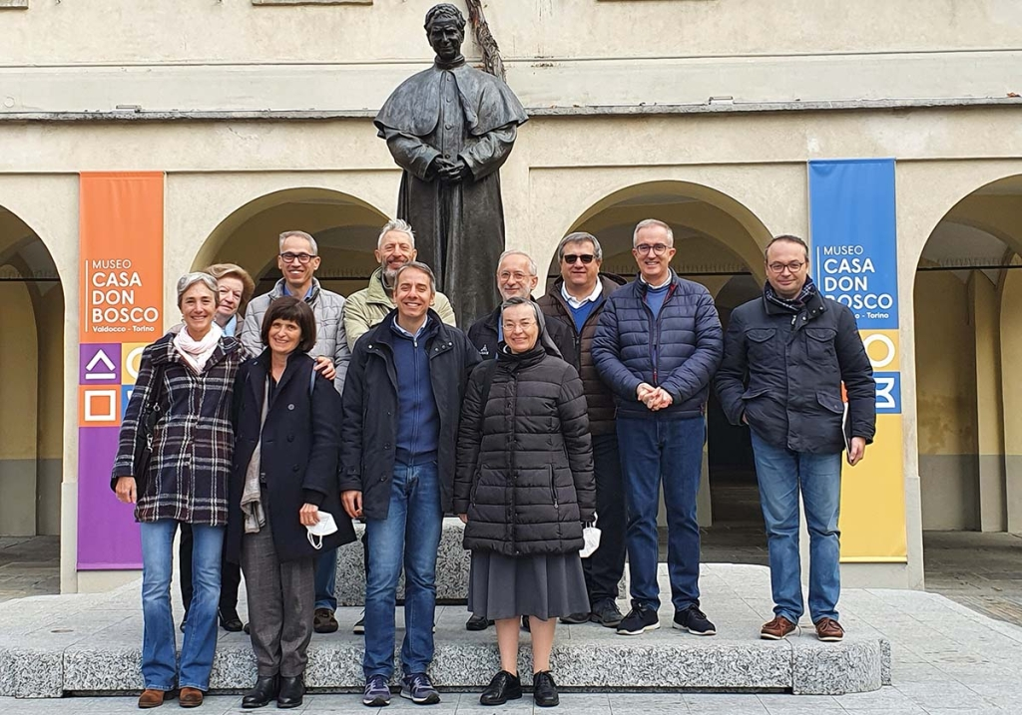
FAMILY CHRONICLE

Turin, Italy - November 2021 - The new Presidency Council of the Association of Mary Help of Christians (ADMA), elected on October 24, during the 31st Marian Day, held its first meeting in Valdocco on Saturday 13 November. The new Council, chaired by Renato Valera, met and began to work on an outline prepared by the outgoing council. This "legacy" and gift serves as a reflection on the journey of the association in the last four years and on what is important to preserve, what is important to grow, the points that need attention and the projects undertaken. There were many resonances among the new councillors in highlighting aspects important for the whole association, in Valdocco and in the world: entrustment to Mary, centrality of the journey of faith anchored to the two columns of the Eucharist and Mary, simplicity in style and organization, centrality of communion in relationships, hospitality, the importance of prayer and formation, the accompaniment of families and young people with their families, attention to the weak and the ordinary people, the strengthening of Salesian identity and charism.

In addition, positions were assigned to the new Councillors for the service of the mission. President: Renato Valera - Vice-president: Chiara Audasso - Treasurer: Paolo Peirone - Secretariat: Maria Pia Gallo - Councillor for communication: Chiara Audasso - Councillor for youth ministry and the family: Beppe Sardella - Councillor for formation: Tullio Lucca - Councillor for the animation and promotion of ADMA worldwide: Giovanni Scavino - Councillor for the coordination and animation of local ADMA Italy: Paolo Peirone - Councillors for the animation of the local ADMA in Valdocco: Tullio Lucca, Luciana Bianchetti - Each councillor will thus have special attention and responsibility for a specific area, being able to involve other members of the association, in order to form work teams that will help the association to grow in faith, in love for Mary and in the service of our brothers and sisters.

The lay members of the council are accompanied by: Don Alejandro Guevara, SDB - World Animator of the Association. Don Roberto Carelli, SDB – Delegate for pastoral care of the family and formation. Sr. Lucrecia Uribe, FMA - FMA World Delegate. Sr. Marilena Balcet, FMA - FMA Piedmont Delegate.

